Introduction
contents
About the <<Your State>>
Tuberculosis Program Manual 1.2
Purpose 1.2
Audience 1.2
How to Use This Manual 1.3
Portable document format 1.3
Hyperlinks 1.3
Cross-references 1.3
Forms 1.3
Bookmarks 1.4
Printing 1.5
Icons 1.6
Abbreviations 1.7
Purpose of Tuberculosis Control 1.10
<<Your State>> Laws and Rules
on Tuberculosis Control 1.11
Objectives and Standards 1.12
Quality of care 1.12
National and state program objectives 1.13
Standards 1.17
Roles, Responsibilities, and
Contact Information 1.18
State tuberculosis program staff 1.18
Tuberculosis consultants 1.18
Local public health agencies 1.19
Private medical providers 1.19
Laboratories 1.20
Resources and References 1.21

About the
<<Your State>> Tuberculosis Program Manual

Purpose
This manual is designed to present the key steps and crucial information needed to perform tuberculosis (TB) control tasks in states in which TB occurs with a low incidence—defined by the Centers for Disease Control and Prevention (CDC) as less than 3.5 cases/100,000 population/year. Where additional or more detailed information is available, hyperlinks to CDC guidelines and other resources are provided.
The <<Your State>>Tuberculosis Program Manual is based on a template created by an advisory group convened during CDC Task Order #6. The advisory group developed the template’s format and created its content by reviewing other TB control manuals, current CDC guidelines, and needs in the four low-incidence states of Idaho, Montana, Utah, and Wyoming.

Audience
<<Revise the audience listing to reflect the target audiences in your state.>>
The audience for this manual includes city/county/regional public health nurses, outreach workers, physicians, and public health officers; Indian Health Services (IHS) staff; physician consultants; private sector physicians; infection control nurses in hospitals and other facilities; disease intervention specialists; state epidemiologists; and state TB program staff.

How to Use This Manual

Portable Document Format
This manual is available electronically as a portable document format (PDF) file. To view the PDF file, you will need the free Adobe Reader, available at this hyperlink: http://www.adobe.com/products/acrobat/readstep2.html .

Hyperlinks
When viewing this manual online with an Internet connection, you can go directly to underlined Web addresses by clicking on them.

Cross-References
When viewing this manual electronically, you can go directly to other sections or topics in the manual by clicking on text next to this icon: | 

Forms
Required and recommended forms are available on the <<Web page name>> at <<Web address>>. This icon alerts you that forms are available: | 

Bookmarks
In PDF files, you can use bookmarks to go quickly to a section or topic. If the bookmarks are not visible on the left, click the Bookmarks icon or tab on the left of the window.
To view sections and topics in the bookmarks list:
- Click + to see a more detailed list.
- Click – to hide the more detailed list.
To go to a section or topic in the bookmarks list, point to its name and left-click.
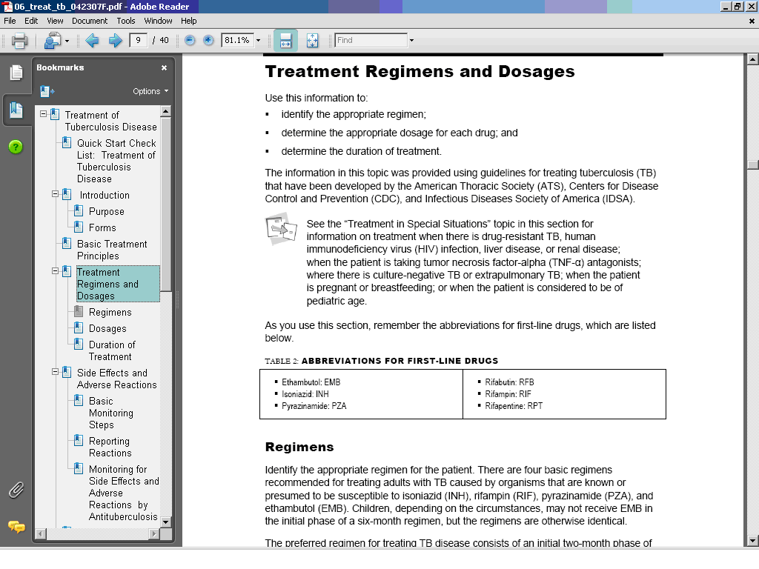

Printing
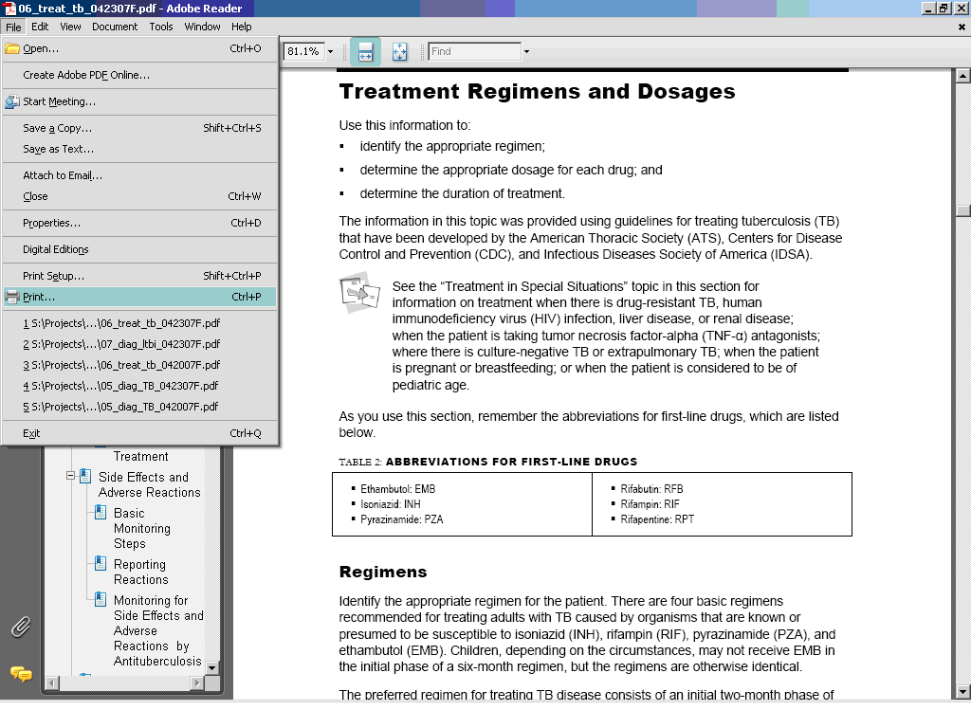
To access the print dialog box, click the File drop-down menu, click Print, and then make your selections in the Print dialog box.
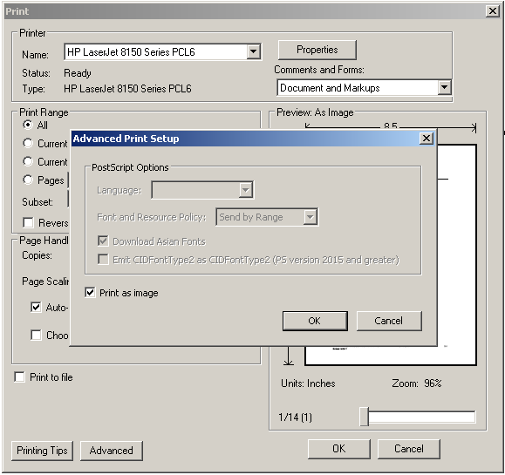 | Some printers have older printer drivers that cause spaces to appear in the middle of words. To avoid this problem, select File/Print, click the Advanced button, check Print as Image, and then click OK. If you need further assistance with printing, call the Francis J. Curry National Tuberculosis Center’s IT staff at 415-502-5810.

Icons
Throughout the manual, these icons quickly cue you into important information and other resources:

 | This warns about high-consequence information you must understand when performing the task.
 | This signals when you should call to report or to consult on the task.
 | This highlights special considerations for pediatric patients.
 | This suggests another relevant area in the manual or another resource that you may want to review.
 | This alerts you that a form is available for the task.

Abbreviations
Refer to the list below for abbreviations used in the manual.

ACET Advisory Council for the Elimination of Tuberculosis
ACH air changes per hour
AFB acid-fast bacilli
AIDS acquired immunodeficiency syndrome
AII airborne infection isolation
ALT alanine aminotransferase
ARPE Aggregate Report for Program Evaluation
ART antiretroviral therapy
AST aspartate aminotransferase
ATS American Thoracic Society
BAMT blood assay for Mycobacterium tuberculosis
BCG bacille Calmette-Guérin
CDC Centers for Disease Control and Prevention
CT computed tomography
CXR chest radiograph
DNA deoxyribonucleic acid
DOT directly observed therapy
DTBE Division of Tuberculosis Elimination
DTH delayed-type hypersensitivity
ED emergency department
EMB ethambutol
EMS emergency medical service
ESRD end-stage renal disease
FDA U.S. Food and Drug Administration
HAART highly active antiretroviral therapy
HCW healthcare worker
HEPA high-efficiency particulate air
HIPAA Health Insurance Portability and Accountability Act
HIV human immunodeficiency virus
IDSA Infectious Diseases Society of America
IGRA interferon gamma release assay
INH isoniazid
LTBI latent tuberculosis infection
M. tuberculosis Mycobacterium tuberculosis
MDR-TB multidrug-resistant tuberculosis
MIRU mycobacterial interspersed repetitive units
MOTT mycobacterium other than tuberculosis
NAA nucleic acid amplification
NIOSH National Institute for Occupational Safety and Health
NNRTI nonnucleoside reverse transcriptase inhibitors
NTCA National Tuberculosis Controllers Association
NTM nontuberculous mycobacteria
NTNC National Tuberculosis Nurse Coalition
OSHA Occupational Safety and Health Administration
PAPR powered air-purifying respirator
PCR polymerase chain reaction
PI protease inhibitor
PPD purified protein derivative
PZA pyrazinamide
QA quality assurance
QFT QuantiFERON®-TB test
QFT-G QuantiFERON®-TB Gold test
RFB rifabutin
RFLP restriction fragment length polymorphism
RIF rifampin
RNA ribonucleic acid
RPT rifapentine
RVCT Report of Verified Case of Tuberculosis
RZ rifampin and pyrazinamide
TB tuberculosis
TIMS Tuberculosis Information Management System
TNF-α tumor necrosis factor-alpha
TST tuberculin skin test
TU tuberculin units
USCIS U.S. Citizenship and Immigration Services
UVGI ultraviolet germicidal irradiation
XDR-TB extremely drug-resistant tuberculosis

Purpose of Tuberculosis Control
Tuberculosis (TB) is caused by a bacterial organism named Mycobacterium tuberculosis. (These organisms are sometimes called tubercle bacilli.) Mycobacteria can cause a variety of diseases. Some mycobacteria are called tuberculous mycobacteria because they cause TB or diseases similar to TB. These mycobacteria are M. tuberculosis, M. bovis, and M. africanum. Other mycobacteria are called nontuberculous mycobacteria (NTM) because they do not cause TB. One common type of nontuberculous mycobacteria is M. avium complex. Tuberculous mycobacteria readily spread from person to person; nontuberculous mycobacteria do not usually spread from person to person.
The goal of TB control in the United States is to reduce TB morbidity and mortality by doing the following:
- Preventing transmission of M. tuberculosis from persons with contagious forms of the disease to uninfected persons
- Preventing progression from latent TB infection (LTBI) to active TB disease among persons who have contracted M. tuberculosis infection
For information on the transmission of M. tuberculosis and on how LTBI progresses to TB disease, see the Centers for Disease Control and Prevention’s (CDC’s) online course, Interactive Core Curriculum on Tuberculosis (2004), at this hyperlink: http://www.cdc.gov/tb/webcourses/corecurr/index.htm .
The four fundamental strategies to reduce TB morbidity and mortality include the following:
- Early and accurate detection, diagnosis, and reporting of TB cases, leading to initiation and completion of treatment
- Identification of contacts of patients with infectious TB and treatment of those at risk with an effective drug regimen
- Identification of other persons with latent TB infection at risk for progression to TB disease and treatment of those persons with an effective drug regimen
- Identification of settings in which a high risk exists for transmission of M. tuberculosis and application of effective infection control measures
For more information on these strategies and the thinking behind them, see “Controlling Tuberculosis in the United States: Recommendations from the American Thoracic Society, CDC, and the Infectious Diseases Society of America” (MMWR 2005;54[No. RR-12]) at this hyperlink: http://www.cdc.gov/MMWR/PDF/rr/rr5412.pdf .

<<Your State>> Laws and Rules
on Tuberculosis Control
<<Your state>> laws and rules on tuberculosis (TB) are located in <<publication>>.
<<Publication>> at <<Web address>>.

Contact the <<Your State>> TB Program at <<telephone number>> for assistance with interpreting laws and rules regarding TB control.

Objectives and Standards

Quality of Care
For tuberculosis (TB) programs, quality of care is measured by objectives and standards. Such objectives and standards are used as yardsticks to direct the program and measure its success.
Objectives reflect outcomes or results and program desires. Programs require objectives to define expected outcomes and results for case management activities.
Standards are an accepted set of conditions or behaviors that define what is expected and acceptable regarding job duties, performance, and provision of services. The TB control program works to achieve objectives through a series of standards.
<<Modify the text below to reflect your state’s goals, objectives, standards, and regulations.>>

In <<your state>>, TB program objectives and standards are established from the following:

State Laws and Regulations
<<Cite state laws that mandate the objectives and standards of performance.>>
- <<Law/regulation>>
- <<Law/regulation>>

TB Program Agreements, Plans, and Protocols
<<Cite the agreements, strategic plans, and treatment protocols that establish the TB program’s goals, objectives, and standards of performance.>>
- Centers for Disease Control and Prevention (CDC) Cooperative Agreement
- <<Strategic plan>>
- <<Treatment protocols>>

National TB Guidelines
<<List the national organizations or TB guidelines that help to establish the TB program’s goals, objectives, and standards of performance.>>
- American Thoracic Society (ATS)
- Infectious Diseases Society of America (IDSA)
- CDC Division of Tuberculosis Elimination (DTBE) guidelines

National and State Program Objectives
Below are national and state TB program objectives. The CDC program objectives are current as of December 2006. Under each national objective, there is a state objective established by the <<your state>> TB Program, based on <<your state’s>> epidemiology and recent program performance.

<<Insert your state’s objectives below each national objective.>>
Table 1: Program Objectives and Performance Targets
Indicator |  | National Tuberculosis Program Objectives  and Performance Targets
1 | Percent completion of treatment | Increase timely completion of treatment  National Objective: At least 93% of patients with newly diagnosed tuberculosis (TB), for whom therapy for 12 months or less is indicated, will complete treatment within 12 months by 2015.  State Objective: <<Insert objective.>>
2 | TB case rate | Decline in TB rates  - National Objective: The average yearly decline in TB rates in the US born will be >11%.  State Objective: <<Insert objective.>>  - National Objective: The average yearly decline in TB rates in the foreign born will be >4%.  State Objective: <<Insert objective.>>  - National Objective: The TB rate in U.S. born will be <0.7 cases/100,000 by 2015.  State Objective: <<Insert objective.>>  - National Objective: The TB rate in foreign born will be <14 cases/100,000 by 2015.  State Objective: <<Insert objective.>>  - National Objective: The TB rate in U.S.-born black non-Hispanics will be <1.3 cases/100,000 by 2015.  State Objective: <<Insert objective.>>  - National Objective: The TB rate in children <5 years of age will be <0.4/100,000 by 2015.  State Objective: <<Insert objective.>>
3 | Thorough contact investigations | Improve contact identification, evaluation, and treatment  - National Objective: All sputum-AFB-smear-positive TB cases will have at least one contact listed by 2015.  State Objective: <<Insert objective.>>  - National Objective: At least 93% of contacts to sputum-AFB-smear-positive TB cases will be evaluated for infection and disease by 2015.  State Objective: <<Insert objective.>>  - National Objective: At least 88% of infected contacts will start treatment by 2015.  State Objective: <<Insert objective.>>  - National Objective: At least 79% of contacts who start treatment will complete treatment.  State Objective: <<Insert objective.>>
4 | Timely laboratory reporting | Ensure timely laboratory reporting  - National Objective: State public health labs will report 100% of results of culture identification of M. tuberculosis complex to submitter and state TB program within 21 days of receipt of specimen by 2015.  State Objective: <<Insert objective.>>  - National Objective: Increase the percentage of TB patients with initial positive cultures who also are tested for and receive drug susceptibility results to 100% by 2015.  State Objective: <<Insert objective.>>
Source: National TB Indicators Project. Initial Indicators and Performance Targets. Atlanta, GA: CDC Division of Tuberculosis Elimination; November 1, 2006. [Cleared by CDC but unpublished as of December 2006.]

<<In addition to the national program objectives listed above, the CDC has two goals (listed below) that do not have national program objectives established at this time. Specific objectives relating to these two goals will be established in the future. In the meantime, states should review the following two goals and establish objectives that are specific, measurable, and time phased, if applicable. National Goal 2 is listed for reference; it does not apply to low-incidence areas.>>
- National Goal: Increase the percentage of immigrants and refugees designated as Class A, B1, or B2 who are appropriately evaluated and treated. <<Refer to the following Web link, pages 2–6, for classification descriptions: http://www.cdc.gov/ncidod/dq/pdf/ds-forms-instructions.pdf .>>
State Objective: <<Insert objective.>>
- National Goal: For jurisdictions with greater than 50 reported cases of TB occurring annually in U.S.-born African Americans, decrease the case rate.
State Objective: <<Insert objective.>>

Standards
Program standards are what the stakeholders of the TB program would consider to be "reasonable expectations" for the program. For TB, standards have been established by nationally accepted authorities, such as the American Thoracic Society (ATS), the Infectious Diseases Society of America (IDSA), and the CDC, and generally recognized TB control experts, such as the National Tuberculosis Nurse Coalition (NTNC) and the National Tuberculosis Controllers Association (NTCA). Many state programs, and some local TB control programs, have established their own standards and objectives for case management. <<As of 2008, the NTNC currently is revising its Tuberculosis Nursing manual, which will contain the most current program, structural, and patient care standards that the NTNC recommends. Check for updates at this hyperlink: http://tbcontrollers.org/.>>
The standards of care for the medical treatment and control of TB are published jointly by ATS, IDSA, and the CDC. These standards should be available for reference by each TB staff member. The standards are included in the following guidelines:
- ATS, CDC, IDSA. “Controlling Tuberculosis in the United States: Recommendations from the American Thoracic Society, CDC, and the Infectious Diseases Society of America” (MMWR 2005;54[No. RR-12]). Available at: http://www.cdc.gov/mmwr/PDF/rr/rr5412.pdf .
- ATS, CDC, IDSA. “Diagnostic Standards and Classification of Tuberculosis in Adults and Children” (Am J Respir Crit Care Med 2000;161[4 Pt 1]). Available at: http://www.cdc.gov/tb/pubs/PDF/1376.pdf .
- ATS, CDC, IDSA. “Treatment of Tuberculosis” (MMWR 2003;52[No. RR-11]). Available at: http://www.cdc.gov/mmwr/PDF/rr/rr5211.pdf .
- CDC, NTCA. “Guidelines for the Investigation of Contacts of Persons with Infectious Tuberculosis: Recommendations from the National Tuberculosis Controllers Association and CDC” (MMWR 2005;54 [No. RR-15]). Available at: http://www.cdc.gov/mmwr/pdf/rr/rr5415.pdf .
- CDC. “Guidelines for Preventing the Transmission of Mycobacterium tuberculosis in Health-care Settings, 2005” (MMWR 2005;54[No. RR-17]). Available at: http://www.cdc.gov/mmwr/pdf/rr/rr5417.pdf .
- CDC. “Targeted Tuberculin Testing and Treatment of Latent Tuberculosis Infection” (MMWR 2000;49[No. RR-6]). Available at: http://www.cdc.gov/mmwr/PDF/rr/rr4906.pdf .
For additional guidelines, see the Division of Tuberculosis Elimination’s “TB Guidelines” Web page (Division of Tuberculosis Elimination Web site; accessed November 25, 2006). Available at: http://www.cdc.gov/tb/pubs/mmwr/Maj_guide/default.htm .

Roles, Responsibilities,
and Contact Information

State Tuberculosis Program Staff
<< Describe the roles and responsibilities of your state-level staff, and provide their contact information. Add rows as necessary.>>
Table 2: State Tuberculosis Program Staff Roles, Responsibilities, and Contact Information
Roles and Responsibilities | Contact Information
<<Title>>  <<Description of role, responsibilities, questions answered, services provided>> | <<Name, degrees>>  <<Agency>>  <<Address>>  Tel: <<Telephone number>>  Fax: <<Fax number>>  E-mail: <<E-mail>>

Tuberculosis Consultants
<<Describe the roles and responsibilities of your tuberculosis consultants, and provide their contact information where indicated below. Add rows as necessary.>>
Table 3: tuberculosis Consultants’ Roles, Responsibilities, and Contact Information
Roles and Responsibilities | Contact Information
<<Name, degrees>>  <<Description of role, responsibilities, questions answered, services provided>> | <<Title>>  <<Agency>>  <<Address>>  Tel: <<Telephone number>>  Fax: <<Fax number>>  E-mail: <<E-mail>>

Local Public Health Agencies
<<Describe the roles and responsibilities of local public health agencies below. Explain their roles and responsibilities for tuberculosis diagnosis and treatment and for case management and how their roles relate to the roles and responsibilities of private providers. To save time and reduce the need for updates, do not add specific information for each agency. Instead, hyperlink to a directory that lists all agencies and their contact information.>>
Table 4: local public health agencies’ Roles, Responsibilities, and Directory
Roles and Responsibilities | Contact Information
<<Description of role, responsibilities, questions answered, services provided>> | <<Add a hyperlink to a directory of your state’s local health agencies, Indian Health Services (IHS), and tribal clinics.>>

Private Medical Providers
<<Describe the roles and responsibilities of private providers in your state. Explain their roles and responsibilities for tuberculosis diagnosis and treatment and how their roles relate to the roles and responsibilities of public health staff.>>
Table 5: roles and responsibilities of private medical providers For tuberculosis Diagnosis and Treatment
Roles and Responsibilities
<<Description of role, responsibilities, questions answered, services provided>>

Laboratories
<<Describe the roles and responsibilities of public and private laboratories in your state. In this table, enter information on the state laboratory and other laboratories that your program considers important in terms of services offered or number of specimens received. For your readers’ convenience—and if you think they will use the manual sections as standalone references—you may want to copy this table into the Laboratory Services section under the “Available Laboratory Tests” topic after you have customized the table for this section.>>
Table 6: Roles, Responsibilities, and Contact Information of Laboratories
Role and Responsibilities | Contact Information
State Laboratory  <<Description of role, questions answered, laboratory services provided>> | <<Laboratory Name>>  <<Contact name, degrees, title>>  <<Address>>  Tel: <<Telephone number>>  Fax: <<Fax number>>  E-mail: <<E-mail>>
Private Laboratories  <<Description of role, questions answered, laboratory services provided>> | <<Laboratory Name>>  <<Contact name, degrees, title>>  <<Address>>  Tel: <<Telephone number>>  Fax: <<Fax number>>  E-mail: <<E-mail>>  <<Laboratory Name>>  <<Contact name, degrees, title>>  <<Address>>  Tel: <<Telephone number>>  Fax: <<Fax number>>  E-mail: <<E-mail>>

Resources and References

Resources
- CDC. “Framework for Program Evaluation in Public Health” (MMWR 1999;48[No. RR-11]). Available at: ftp://ftp.cdc.gov/pub/Publications/mmwr/rr/rr4811.pdf .
- Division of Tuberculosis Elimination. A Guide to Developing a TB Program Evaluation Plan (Division of Tuberculosis Elimination Web site; accessed November 1, 2006). Available at: http://www.cdc.gov/tb/Program_Evaluation/default.htm .
- Division of Tuberculosis Elimination. Understanding the TB Cohort Review Process: Instruction Guide (Division of Tuberculosis Elimination Web site; accessed November 1, 2006). Available at: http://www.cdc.gov/tb/pubs/cohort/default.htm .
- New Jersey Medical School National Tuberculosis Center. Planning & Implementing the TB Case Management Conference: A Unique Opportunity for Networking, Peer Support and Ongoing Training (Newark, NJ; 2004). Available at: http://www.umdnj.edu/globaltb/products/planning&implementing.htm .

References

CDC. Progressing toward tuberculosis elimination in low-incidence areas of the United States: recommendations of the Advisory Council for the Elimination of Tuberculosis. MMWR 2005;51(No. RR-5):1.
ATS, CDC, IDSA. Controlling tuberculosis in the United States: recommendations from the American Thoracic Society, CDC, and the Infectious Diseases Society of America. MMWR 2005;54(No. RR-12):14.
ATS, CDC, IDSA. Controlling tuberculosis in the United States: recommendations from the American Thoracic Society, CDC, and the Infectious Diseases Society of America. MMWR 2005;54(No. RR-12):15.

