Contact Investigation
contents

Introduction 10.2
Purpose 10.2
Policy 10.3
Forms 10.4
Structure of a
Contact Investigation 10.5
Basic steps of a contact investigation 10.5
Contact investigation plan 10.5
Decision to Initiate a
Contact Investigation 10.6
Factors predicting transmission
of tuberculosis 10.6
Deciding to initiate a contact investigation 10.9
Time Frames for
Contact Investigation 10.12
Information about the index patient
and transmission sites 10.12
Contact evaluation and treatment 10.14
Ongoing management activities 10.16
Infectious Period 10.18
Index Patient Interviews 10.21
Preinterview preparation 10.21
General guidelines for interviewing
an index patient 10.22
Field Investigation 10.23
Contact Priorities 10.25
Index patient with positive acid-fast bacilli
sputum smear results
or cavitary tuberculosis 10.26
Index patient with negative acid-fast bacilli
sputum smear results 10.29
Index patient with negative bacteriologic
results and abnormal chest radiographs
not consistent with tuberculosis 10.31
Contact Evaluation, Treatment, and
Follow-up 10.32
Immunocompromised contacts
and children under five 10.33
Immunocompetent adults and
children five and older
(high- and medium-priority contacts) 10.36
Contacts with prior positive
tuberculin skin tests 10.39
When to Expand a
Contact Investigation 10.41
Guidelines for expanding an investigation 10.41
Low-priority contacts 10.43
Data Management and Evaluation
of Contact Investigations 10.45
Reasons contact investigation
data are needed 10.45
Approach 10.46
Index patient and contact data 10.47
Evaluation of a contact investigation 10.51
Outbreak Investigation 10.52
Definition of a tuberculosis outbreak 10.52
Deoxyribonucleic acid genotyping 10.53
<<Your State’s>> tuberculosis
outbreak response plan 10.53
Resources and References 10.54

Introduction

Purpose
A contact investigation is the process of identifying, examining, evaluating, and treating all persons who are at risk for infection with Mycobacterium tuberculosis due to recent exposure to a newly diagnosed or suspected case of pulmonary, laryngeal, or pleural tuberculosis (TB).
The primary goal of a contact investigation is to do the following:
- Identify persons who were exposed to an infectious case of TB.
- Ensure that contacts receive these evaluation services:
- Testing for M. tuberculosis infection
- Screening for TB disease
- Medical evaluation, if indicated
- Prompt initiation of treatment for latent tuberculosis infection (LTBI) if at high risk for developing TB disease (younger than five years of age or immunocompromised)
- A complete, standard course of treatment, unless medically contraindicated
In addition, the following are secondary goals of a contact investigation:
- Stop transmission of M. tuberculosis by identifying persons with previously undetected infectious TB.
- Determine whether a TB outbreak has occurred (in which case, an expanded outbreak investigation should ensue).
Use this section to understand and follow national and <<your state>> guidelines to address the following:
- Decide when to initiate a contact investigation.
- Understand the time frames for key contact investigation activities.
- Estimate the infectious period.
- Conduct index patient interviews.
- Assign priorities to contacts.
- Complete contact evaluation, treatment, and follow-up.
- Determine when to expand a contact investigation.
- Manage data and evaluate contact investigations.
- Conduct an outbreak investigation.
Except in rare cases, every case of TB begins as a contact to a person with active pulmonary, laryngeal, or pleural TB disease. For this reason, the Centers for Disease Control and Prevention (CDC) has identified contact investigations (i.e., seeking and evaluating contacts) as a fundamental strategy for the prevention and control of TB. To control and prevent TB, our healthcare resources and efforts in <<your state>> should be directed to meeting the priorities outlined in the 2005 “Controlling Tuberculosis in the United States: Recommendations from the American Thoracic Society, Centers for Disease Control and Prevention, and the Infectious Diseases Society of America.” One of the recommended strategies for achieving the goal of reduction of TB morbidity and mortality is prompt identification of contacts to patients with infectious TB and timely treatment of those at risk with an effective drug regimen. National recommendations for contact investigations are provided in the CDC’s “Guidelines for the Investigation of Contacts of Persons with Infectious Tuberculosis: Recommendations from the National Tuberculosis Controllers Association and CDC, and Guidelines for Using the QuantiFERON®-TB Gold Test for Detecting Mycobacterium tuberculosis Infection, United States” (MMWR 2005;54[No. RR-15]:1–49).
One of the major challenges to successful control of TB is in protecting contacts of persons with infectious TB and in preventing and responding to TB outbreaks. Reducing the risk of TB among contacts through the development of better methods of identification, evaluation, and management would lead to substantial personal and public health benefits and facilitate progress toward eliminating TB in the United States.
The evaluation of contacts of cases of infectious TB is one of the most productive methods of identifying adults and children with LTBI at high risk for progression to TB disease and persons in the early stages of TB disease. Contact investigations, therefore, serve as an important means of detecting TB cases and at the same time identify persons in the early stage of LTBI, when the risk for progression to TB disease is high and the benefit of treatment is greatest. A study showed that improvements in contact investigations might have prevented 17 (10%) of 165 pediatric TB cases in California in 1994.

Policy
A contact investigation is recommended for the following forms of suspected or confirmed TB because they are likely to be infectious:
- Pulmonary, laryngeal, or pleuropulmonary disease with either pulmonary cavities, or respiratory specimens that have acid-fast bacilli (AFB) on microscopy, or (especially) both.
- Persons with AFB sputum smear negative results are less likely to be infectious but are still capable of infecting others.

 | For roles and responsibilities, refer to the “Roles, Responsibilities, and Contact Information” topic in the Introduction.

State Laws and Regulations
<<Cite state laws that mandate contact investigation policy and/or procedures. If there are no applicable laws/regulations, delete this table.>>

Program Standards
<<List program standards that apply to contact investigation activities. If there are no applicable standards, delete this table.>>

Forms
 | For each investigation, complete the <<form name>> on the reporting schedule in Table 3: Required Reports in the “Required Reports from Local Public Health Agencies to the <<Your State>> Tuberculosis Program” topic in the Surveillance section. Forms are available on the <<Web page name>> at <<Web address>>.
<<Identify any reporting and recordkeeping requirements.>>
Reporting requirements: << List state reporting requirements.>>
Recordkeeping requirements: << List state recordkeeping requirements.>>

Structure of a Contact Investigation

Basic Steps of a Contact Investigation
A successful contact investigation requires the careful gathering and evaluation of detailed information, often involving many people. In general, contact investigations follow a process that includes these steps:
- Preinterview preparation
- Index patient interviews
- Field investigation
- Risk assessment for Mycobacterium tuberculosis transmission
- Decision about priority of contacts
- Evaluation of contacts
- Treatment and follow-up of contacts
- Decision about whether to expand testing
- Evaluation of contact investigation activities,
Although these steps are presented in sequence above, it is important to remember that contact investigations do not always follow a predetermined sequence of events.

Contact Investigation Plan
The investigation plan starts with information gathered during interviews and site visits. It should include a registry of the contacts, their assigned priorities, and a written timeline. The timeline sets expectations for monitoring the progress of the investigation, and it informs public health officials whether additional resources are needed for finding, evaluating, and treating the high- and medium-priority contacts.
For more information on timelines, see Table 2: Time Frames for Investigating the Index Patient and the Sites of Transmission and Table 3: Time Frames for Contact Evaluation and Treatment in this section’s topic “Time Frames for Contact Investigation.”
The plan is a work in progress and should be revised if additional information indicates a need to expand a contact investigation. It is part of the permanent record of the overall investigation for later review and program evaluation.

Decision to Initiate a Contact Investigation

Factors Predicting Transmission of Tuberculosis
Decide when to initiate a contact investigation using the criteria provided in this topic. Competing demands restrict the resources that can be allocated to contact investigations. Therefore, public health officials must decide which contact investigations are more significant and which contacts to evaluate first.
The index patient is the first patient that comes to the investigator’s attention as an indicator of a potential public health problem. Whether or not to investigate an index patient depends upon factors predicting transmission. See Table 1: Index Patient Factors Increasing Transmission Risk. In addition, other information about the index patient, such as social habits or workplace environments, can influence the investigative strategy.
Record your decision and rationale for initiating a contact investigation on <<form name>>.
Table 1. Index patient factors increasing Transmission risk
Characteristics of the Index Patient | Behaviors of the Index Patient
- Pulmonary, laryngeal, or pleuropulmonary tuberculosis (TB)  - Positive acid-fast bacilli sputum smear results  - Cavitation on chest radiograph  - Adolescent or adult patient  - Lack of treatment or ineffective treatment of TB disease | - Frequent coughing  - Sneezing  - Singing  - Close social network
Source: CDC. Guidelines for the investigation of contacts of persons with infectious tuberculosis: recommendations from the National Tuberculosis Controllers Association and CDC, and Guidelines for using the QuantiFERON®-TB Gold test for detecting Mycobacterium tuberculosis infection, United States. MMWR 2005;54(No. RR-15):4.

Anatomical Site of Disease
Ordinarily, patients with pulmonary or laryngeal tuberculosis (TB) are the only ones who can transmit their infection. For contact investigations, pleural disease is grouped with pulmonary disease because sputum cultures can yield Mycobacterium tuberculosis even when no lung abnormalities show on radiography. Rarely, extrapulmonary TB causes transmission during medical procedures, such as autopsy and embalming, that release aerosols.

Sputum Bacteriology
The relative infectiousness increases when the sputum culture results are positive and increases further when the acid-fast bacilli (AFB) sputum smear results are also positive. The significance of results from respiratory specimens other than expectorated sputum, such as bronchial washings or bronchoalveolar lavage fluid, is undetermined. Expert opinion recommends that these specimens be regarded as equivalent to sputum.

Radiographic Findings
Patients who have lung cavities observed on a chest radiograph are more infectious than patients with noncavitary disease. This is an independent predictor after bacteriologic findings are taken into account. The significance of small lung cavities that are detectable with computerized tomography (CT), but not with plain radiography, is undetermined.
Isolated instances of highly contagious endobroncheal TB in severely immunocompromised patients who temporarily had normal chest radiographs have contributed to outbreaks. The number and relative significance of such instances is unknown, but in one case series with human immunodeficiency virus (HIV)-infected TB patients, 3% who had positive AFB sputum smears had normal chest radiographs at the time of diagnosis.

Social Characteristics
Social issues can influence transmission. To assess the risk of transmission, it is important to consider the index patient’s social factors, such as a close social network, residential setting or homelessness, employment, work setting, non-work-related activities, recent arrival from a foreign country, substance abuse, and intravenous
drug use.

Age
Transmission from children younger than ten years of age is unusual, although it has been reported in association with those pulmonary forms of disease typically seen in adults. Contact investigations to evaluate transmission from pediatric cases should not be undertaken, except for those unusual cases. However, children younger than five years with TB, regardless of the site of disease, should have a contact investigation to identify the source case. A source-case investigation seeks the source of recent M. tuberculosis infection, perhaps newly diagnosed TB disease. TB disease in children younger than five years typically indicates that the infection is recent. Young children usually do not transmit TB to others, and their contacts are unlikely to be infected because of exposure to them.

Human Immunodeficiency Virus Status
Evaluation of HIV status needs to be done promptly since progression to active TB may occur within weeks of exposure among individuals with acquired immunodeficiency syndrome (AIDS). HIV-infected TB patients with low CD4 T-cell counts frequently have chest radiographic findings that are not typical of pulmonary TB. In particular, they are more likely to have mediastinal adenopathy and less likely to have upper-lobe infiltrates and cavities. The atypical radiographic findings increase the potential for delayed diagnosis, which increases transmission. However, HIV-infected patients who have pulmonary or laryngeal TB on average are only as contagious as similar patients who are not HIV infected. Contacts to HIV-infected index TB cases are also more likely to be HIV infected. Therefore, for all persons who were exposed to HIV-infected TB cases (or those with risk factors for HIV) and whose infection status is unknown, HIV counseling and testing is recommended. Regardless of known HIV status, HIV counseling should always be recommended for all patients as a part of the screening process.

After Starting Chemotherapy
TB patients rapidly become less contagious while under treatment. This has been corroborated by measuring the number of viable M. tuberculosis organisms in sputa and by observing infection rates in household contacts. However, the exact rate of decrease cannot be predicted for individual patients, and an arbitrary determination is required for each.

Treatment After Exposure to Drug-Resistant Tuberculosis
 | Drug susceptibility results for the M. tuberculosis isolate from the index patient (i.e., the presumed source of infection) are absolutely necessary for selecting the treatment regimen.
Resistance to only isoniazid (INH) leaves the option of four months of daily rifampin (RIF), but resistance to both INH and RIF constitutes multidrug-resistant TB (MDR-TB). If this is the case, all the potential regimens are poorly tolerated to some extent, while none of these regimens have been tested fully for efficacy. Therefore, a consultation with a physician having expertise in this area is strongly recommended for selecting a regimen and managing the care of contacts. Monitor contacts who are suspected to be infected with multidrug-resistant M. tuberculosis for two years after exposure.

Deciding to Initiate a Contact Investigation
Consider a contact investigation for any patient with confirmed or suspected pulmonary, laryngeal, or pleuropulmonary TB. Refer to Figure 1 to help determine whether to start a contact investigation.
Figure 1: decision to initiate a contact investigation
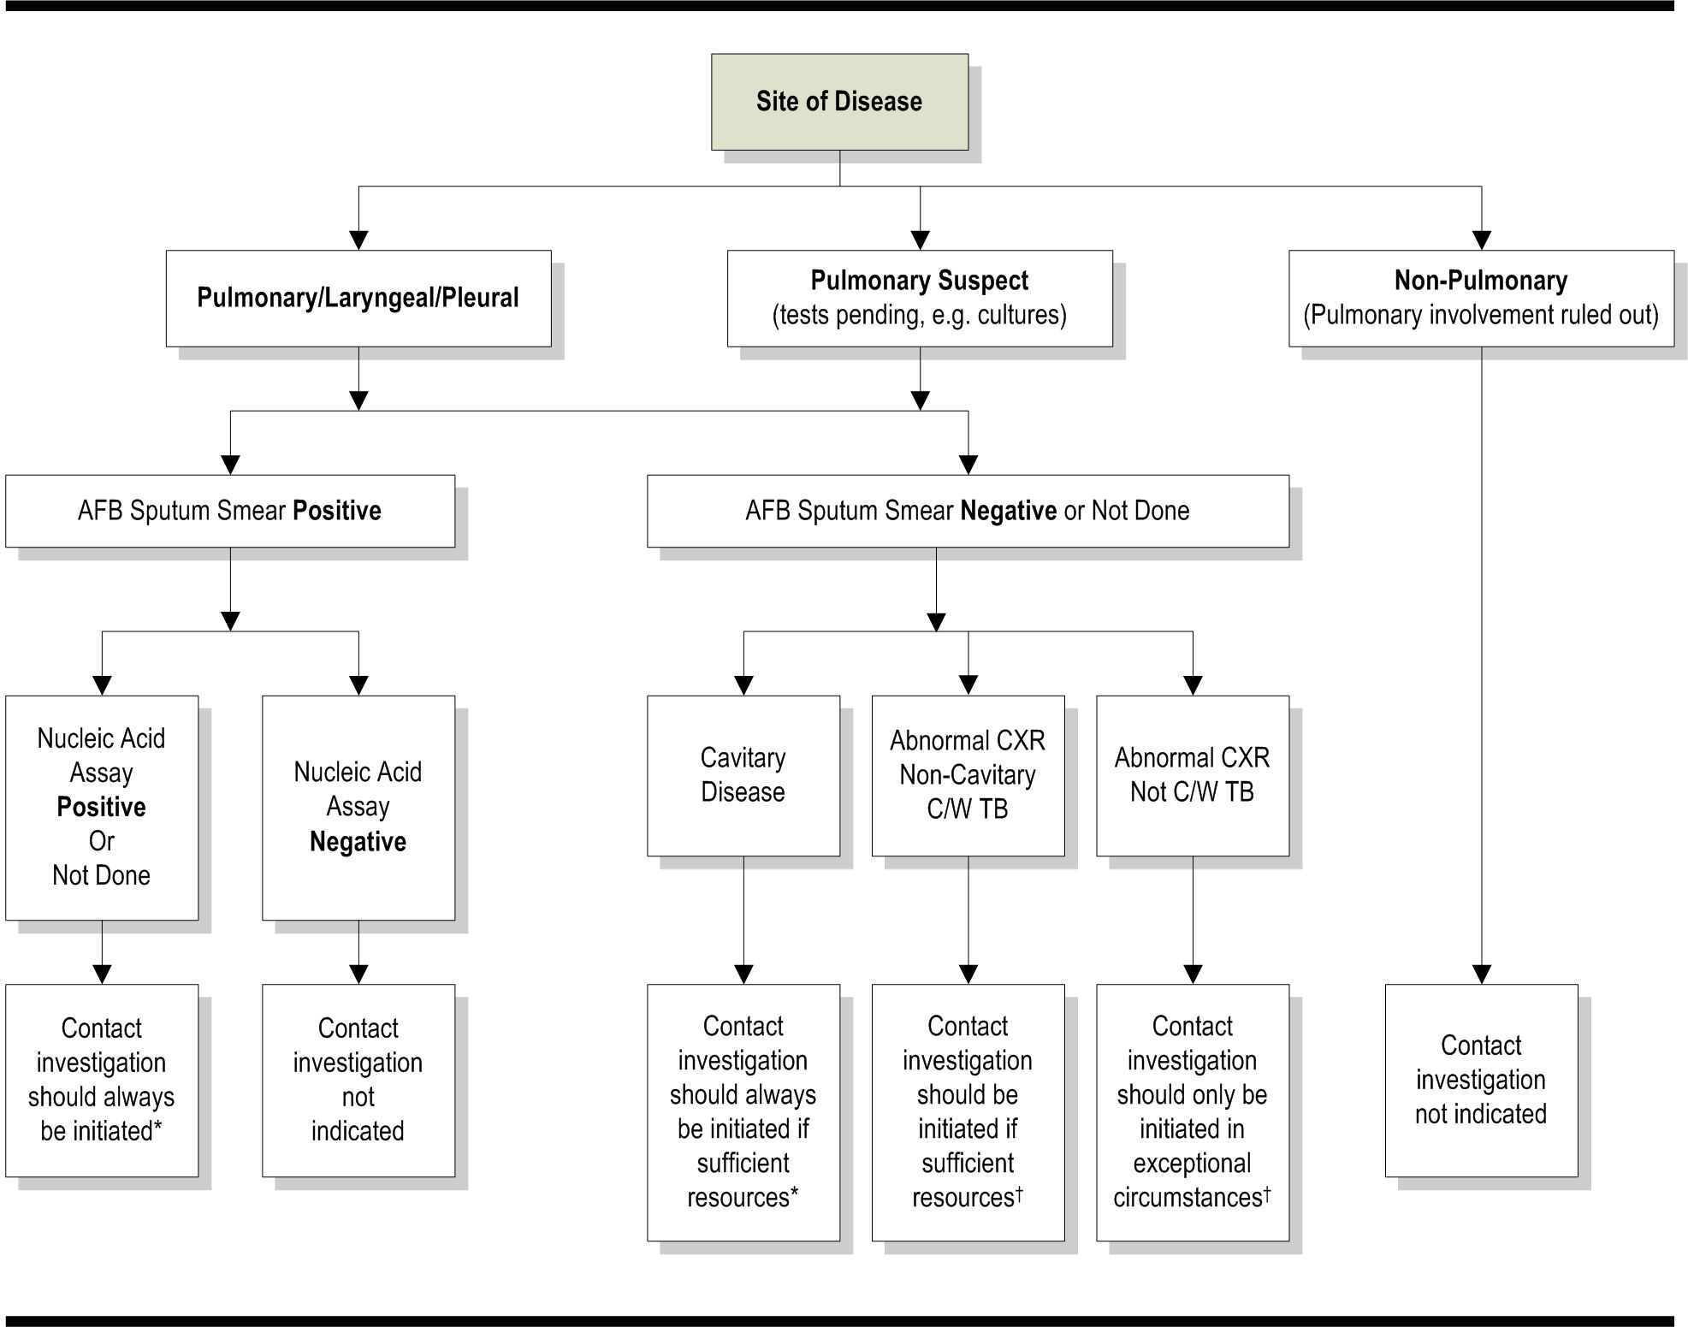

Definitions of abbreviations: AFB = acid-fast bacilli; C/W = consistent with; CXR = chest radiograph; TB = tuberculosis.
* Use time frames from the middle column of Table 2 in the “Time Frames for Contact Investigation” topic.
† Use time frames from the right-hand column of Table 2 in the “Time Frames for Contact Investigation” topic.
Source: CDC. Guidelines for the investigation of contacts of persons with infectious tuberculosis: recommendations from the National Tuberculosis Controllers Association and CDC, and guidelines for using the QuantiFERON®-TB Gold test for detecting Mycobacterium tuberculosis infection, United States. MMWR 2005;54(No. RR-15):5.

In general, a contact investigation should be promptly initiated for an AFB sputum smear-positive pulmonary TB suspect. However, many AFB sputum smear-positive suspects may turn out to have nontuberculous mycobacteria (NTM) instead of M. tuberculosis. An approved nucleic acid amplification (NAA) test for M. tuberculosis can be used to avoid unnecessary contact investigations for suspects with NTM, particularly in patients who are at low risk for TB.
If AFB are not detected by microscopy of three sputum smears, an investigation is still recommended if the chest radiograph shows cavities in the lung. Small parenchymal cavities that can be detected only by computerized imaging techniques (e.g., computed tomography [CT], computerized axial tomography [CAT] scan, or magnetic resonance imaging [MRI] of the chest) are not included in these guidelines.
When sputum samples have not been collected, either because of an oversight or the patient’s inability to expectorate, results from other types of respiratory specimens (e.g., gastric aspirates or bronchoalveolar lavage) may be interpreted in the same way as in the above recommendations. However, whenever feasible, sputum samples for each case should be collected before or while initiating chemotherapy.
A contact investigation may still be considered for high-risk contacts of suspects with non-cavitary disease and negative AFB sputum smears. The decision depends on the amount of resources that can be allocated and on whether goals are being met for higher priority contact investigations.
Contact investigations generally should not be initiated around index patients who have suspected TB disease and minimal diagnostic findings in support of pulmonary TB. Possible exceptions can be found during outbreak investigations, especially when vulnerable or susceptible contacts are found, or during a source-case investigation. Outbreak investigations and source-case investigations are explained briefly below.
- Outbreak Investigation: Definitions for TB outbreaks are relative to the local context. Outbreak cases can be distinguished from other cases only when some association in time, location, patient characteristics, or M. tuberculosis attributes (e.g., drug resistance or genotype) becomes apparent. In low-incidence jurisdictions, any temporal cluster will cause suspicion regarding an outbreak. In places where cases are more common, clusters can be obscured by the baseline incidence rate until suspicion is triggered by a noticeable increase, a sentinel event (e.g., pediatric cases), or related M. tuberculosis isolates.
For more information on outbreak investigations, see the “Outbreak Investigation” topic in this section.
- Source-Case Investigation: A source-case investigation seeks the source of recent M. tuberculosis infection, perhaps newly diagnosed TB disease. A source case or patient is the original source of infection for secondary cases or contacts. The source case can be, but is not necessarily, the index patient.
For more information on source-case investigations, see the CDC’s “Guidelines for the Investigation of Contacts of Persons with Infectious Tuberculosis Cases” (MMWR 2005;54[No. RR-15]: 31) at this hyperlink: http://www.cdc.gov/mmwr/pdf/rr/rr5415.pdf .

Time Frames for Contact Investigation
Use this topic to understand the time frames for key contact investigation activities. A suspected or confirmed case of tuberculosis (TB) becomes designated as an “index patient” when that person is the first patient to appear as an indicator of a potential public health problem. An investigation is launched because of an index patient, and the investigation often starts with an interview of the index patient.

Information about the Index Patient
and Transmission Sites
Comprehensive information about an index patient is the foundation of a contact investigation. This information includes the disease characteristics, the onset date of the illness, names of contacts, exposure locations, and current medical factors, such as initiation of effective treatment and drug susceptibility results.
The infectiousness of the index patient determines the recommended time frames for pursuing the investigation. Indications of infectiousness include symptoms (such as cough, fever, weight loss, and night sweats), a positive acid-fast bacilli (AFB) sputum smear, a positive nucleic acid amplification (NAA) test, cavitary disease, or an abnormal chest radiograph consistent with TB.
<<Table 2 notes time frames recommended in the Centers for Disease Control and Prevention (CDC) guidelines for contact investigation. Modify the time frames to reflect local practices, laws, regulations, and resources.>> Refer to Table 2: Time Frames for Investigating the Index Patient and the Sites of Transmission for the recommended time frames for index patient interviews and visits to the residence transmission sites.
Some readers confuse prioritizing an investigation with prioritizing follow-up of individual contacts within an investigation. The following explains the difference between the two:
- The time priority for investigating the index patient and transmission sites is determined by the infectiousness of the index patient. Indications of infectiousness include positive AFB sputum smear results as well as symptoms, positive NAA test results, and chest radiographs showing cavitary disease or abnormalities consistent with TB.
- Priority-ranking contacts for follow-up within an investigation is based on the characteristics of the index patient, the duration and circumstances of the exposure, and the vulnerability/susceptibility of the contacts to progression from Mycobacterium tuberculosis infection to the development of TB disease.
For information on how to determine which contacts are high, medium, and low priority, see the “Contact Priorities” topic in this section.

Table 2: Time frames for Investigating the Index Patient and the Sites of Transmission
 | Suspects Expected to Be Cases of Tuberculosis
Activity | Suspects with Indications of Infectiousness | Suspects without Indications of Infectiousness
First Index Patient Interview  Number of days following notification within which the index patient should be interviewed in person (i.e., not by telephone) | ≤1 Business Day of Reporting | ≤3 Business Days of Reporting
Residence Visit  Number of days following the first index patient interview within which the place of residence of the index patient should be visited | ≤3 Business Days After the First Interview | 3 Business Days After the First Interview
Field Investigation  Number of days following initiation of the contact investigation within which all potential settings for transmission should be visited | 5 Business Days After the Start of the Investigation | 5 Business Days After the Start of the Investigation
Index Patient Reinterviews  Length of time after the first interview within which the index patient should be reinterviewed one or more times for clarification and additional information | 1 or 2 Weeks After the First Interview | 1 or 2 Weeks After the First Interview
Reassessment of the Index Patient
Information about the index patient should be reassessed at least weekly until drug-susceptibility results are available for the Mycobacterium tuberculosis isolate or for 2 months following notification, whichever is longer.
Source: CDC. Guidelines for the investigation of contacts of persons with infectious tuberculosis: recommendations from the National Tuberculosis Controllers Association and CDC, and guidelines for using the QuantiFERON®-TB Gold test for detecting Mycobacterium tuberculosis infection, United States. MMWR 2005;54(No. RR-15):7–8.

Contact Evaluation and Treatment
In addition to the investigation of the index patient and transmission sites, a contact investigation also involves contact follow-up. Refer to Table 3: Time Frames for Contact Evaluation and Treatment to monitor the progress of the investigation and determine whether additional resources are needed for finding, evaluating, and treating the high- and medium-priority contacts. <<Table 3 notes time frames recommended for contact investigation. Modify the time frames to reflect local practices, laws, regulations, and resources.>>
Priority-ranking contacts for investigation is based on the likelihood of infection and the potential hazard to the individual contact if infected. For information on how to determine which contacts are high-, medium-, or low-priority, see the “Contact Priorities” topic in this section.
Table 3: Time Frames for Contact Evaluation and Treatment
Type of Contact | Business Days from Listing of a Contact to Initial Encounter* | Business Days from Initial Encounter to Completion of Medical Evaluation† | Business Days from Completion of Medical Evaluation to Start of Treatment
High-Priority Contact  Index patient with positive acid-fast bacilli (AFB) sputum smear results or cavitary disease on chest radiograph | 3 Business Days After Being Listed in the Investigation | 5 Business Days | 10 Business Days
 | 3 Business Days After Being Listed in the Investigation | 5 Business Days  Children and high-risk contacts can develop complicated tuberculosis (TB) within a few weeks of infection.
High-Priority Contact  Index patient with negative AFB sputum smear results | 3 Business Days After Being Listed in the Investigation | 10 Business Days | 10 Business Days
Medium-Priority Contact  Regardless of AFB sputum smear or culture result | 3 Business Days After Being Listed in the Investigation | 10 Business Days | 10 Business Days
* “Encounter” means a face-to-face meeting, which gives the public health worker a chance to determine whether the contact is generally healthy or ill. The initial encounter also provides opportunities to administer a tuberculin skin test (TST) and to schedule further evaluation.
† The medical evaluation is complete when the contact’s status relative to Mycobacterium tuberculosis infection or TB disease has been determined. A normal exception to this schedule is the delay in waiting for final mycobacteriologic results, but this applies to relatively few contacts.
Source: Adapted from CDC. Guidelines for the investigation of contacts of persons with infectious tuberculosis: recommendations from the National Tuberculosis Controllers Association and CDC. MMWR 2005;54(No. RR-15):9.

Ongoing Management Activities
Ongoing contact follow-up includes testing, medical evaluation, and treatment. Information from contact follow-up guides decisions about whether to expand a contact investigation. Refer to Table 4: Overview of Ongoing Management Activities and Maximum Time Frames to monitor the progress of ongoing contact follow-up and to determine when to decide whether to expand the investigation.
<<Table 4 notes time frames recommended in the California Department of Health Services (CDHS)/California Tuberculosis Controllers Association’s (CTCA) Contact Investigation Guidelines. Repeat tuberculin skin test time frames have been revised to reflect recommendations by NTCA and CDC for contact investigation. Modify the time frames to reflect your state’s practices, laws, regulations, and resources.>>
Table 4: Overview of Ongoing Management Activities and Maximum Time frames
Activity | Purpose | Maximum Time Interval
Review all documentation | To ensure that contact list is complete | Ongoing
Review and assess completeness of each contact’s medical follow-up and treatment plan | To ensure appropriate and complete medical follow-up | 5 business days after each contact’s medical evaluation is completed*
Review and assess the timeliness of initiating the treatment plan | To avoid delays in treatment initiation, particularly in high-risk contacts | 10 business days after each contact’s medical evaluation is completed*
Determine if transmission occurred | To decide whether to expand investigation | At completion of follow-up testing, or if secondary cases are identified
Obtain and review drug-susceptibility results | To determine if contacts are receiving appropriate treatment for latent tuberculosis infection (LTBI) | 1 to 2 months after the index patient’s initial sputum collection date
Repeat tuberculin skin test (TST) if contact is initially TST-negative | To determine if contact has converted (TB Class I to TB  Class II) | 8 to 10 weeks after each contact’s initial TST or last exposure to the index patient†
Reevaluate contacts who were initially TST-negative and started on LTBI treatment (Window Period Treatment for a TB Class I Contact) | To determine if treatment for LTBI should be continued | 8 to 10 weeks after each contact’s initial TST or last exposure to the index patient before the end of the infectious period†
Assess contacts’ adherence with medical follow-up and TB medication | To remove barriers and ensure timely and complete evaluation and follow-up | Monthly, at the time of each visit
Ensure contacts are monitored for adverse reactions and toxicity of LTBI treatment regimens | To prevent development of adverse effects and toxicity from drug regimens | At least monthly while on LTBI treatment
Evaluate problems and concerns that arise and may delay or hamper the contact investigation | To remove barriers and ensure timely and complete evaluation and follow-up | Whenever problems are identified
Collect and analyze data to evaluate the contact investigation | To provide epidemiologic analysis of investigations and to measure performance using indicators that reflect performance objectives | Ongoing
Collect data to complete the Aggregate Reports for Tuberculosis Program Evaluation (ARPE) form | To report on investigation to the Centers for Disease Control and Prevention | Ongoing
* The medical evaluation is complete when the contact’s status relative to Mycobacterium tuberculosis infection or TB disease has been determined. A normal exception to this schedule is the delay in waiting for final mycobacteriologic results, but this applies to relatively few contacts.
† Third TST: In rare circumstances, an infectious index patient with advanced disease can stay infectious for several months. In these circumstances, the second TST for negative contacts should be performed in the usual time frame (8 to 10 weeks). This will identify any contacts who have already converted so they can be evaluated for treatment. However, any household members who remain TST negative and have continued exposure to the infectious index patient should have a third TST 8 to 10 weeks after the index patient becomes noninfectious. This is especially true for contacts who are infants in a household where a resident is culture positive after 3 months or has multidrug-resistant TB. For example, a household member with continued exposure to an infectious index patient had a negative second TST on 3/12/2007. The last date the index patient was infectious was 3/5/2007. The household member should have a third TST 8 to 10 weeks from 3/5/2007. For consultation regarding the appropriateness of a third TST, call <<position>> at <<telephone number>>.
Source: Adapted from: California Department of Health Services (CDHS)/California Tuberculosis Controllers Association (CTCA). Contact investigation guidelines. CDHS/CTCA Joint Guidelines [CTCA Web site]. November 12, 1998:18. Available at: http://www.ctca.org/guidelines/IID1contactinvestigation.pdf . Accessed July 6, 2006.

Infectious Period
Determine the infectious period to focus the investigation on those contacts most likely to be at risk for infection and to set the time frame for testing contacts.
The infectious period is the time frame in which potential exposure to others may have occurred while the patient was infectious or able to transmit tuberculosis (TB). The exact start of the infectious period cannot be determined with any current methods, so a practical estimation is necessary. From expert opinion, an assigned start three months prior to TB diagnosis is recommended for the more infectious patients. Some circumstances may indicate an even earlier start, which should be used instead. The clearest example is when the patient or the patient’s associates were aware of protracted illness, which can exceed one year in extreme examples.
Assemble information from the index patient interview and other sources to estimate the infectious period. Helpful details include the approximate dates that TB symptoms were noticed, bacteriologic results, and the extent of disease—especially the presence of large lung cavities, which imply prolonged illness as well as infectiousness.
Use Table 5: Guide for Estimating the Beginning of the Period of Infectiousness to determine the start of the infectious period.
Table 5: Guide for estimating the beginning of the period of infectiousness
Index Patient Characteristics
Tuberculosis Symptoms |  | Positive Acid-Fast Bacilli Sputum Smear Results |  | Cavitary Chest Radiograph |  | Recommended Beginning of Likely Period of Infectiousness
Yes | No | Yes | No | Yes | No | Recommended Beginning of Likely Period of Infectiousness
✓ |  |  | ✓ |  | ✓ | 3 months prior to symptom onset or first positive finding consistent with tuberculosis (TB) disease (whichever is longer)
✓ |  | ✓ |  | ✓ |  | 3 months prior to symptom onset or first positive finding consistent with TB disease (whichever is longer)
 | ✓ |  | ✓ |  | ✓ | 4 weeks prior to date of suspected diagnosis
 | ✓ | ✓ |  | ✓ |  | 3 months prior to first positive finding consistent with TB
Source: California Department of Health Services Tuberculosis Control Branch; California Tuberculosis Controllers Association. Contact investigation guidelines. Berkeley, CA: California Department of Health Services; 1998; in CDC. Guidelines for the investigation of contacts of persons with infectious tuberculosis: recommendations from the National Tuberculosis Controllers Association and CDC, and guidelines for using the QuantiFERON®-TB Gold test for detecting Mycobacterium tuberculosis infection, United States. MMWR 2005;54(No. RR-15):7.

For the purposes of contact investigation, the end of potential exposure to the infectious case determines the end of the infectious period. The potential for transmission is reduced by the initiation and duration of treatment, the index patient’s response to treatment, and/or the application of effective infection control measures.
In general, for the purposes of contact investigation, the infectious period is closed when exposure to contacts has ended OR when all three of the following criteria are met:
- The index patient is receiving effective treatment (as demonstrated by Mycobacterium tuberculosis susceptibility results) for at least two weeks.
- The index patient has diminished symptoms.
- The index patient exhibits mycobacteriologic response (e.g., decrease in grade of sputum smear positivity detected on sputum-smear microscopy).,
Take careful note of the following exceptions:
- Multidrug-resistant TB (MDR-TB): MDR-TB can extend infectiousness if the treatment regimen is ineffective.
- Signs of infectiousness: Any index patient with signs of extended infectiousness should be continually reassessed for recent contacts.
- Susceptible contacts: Apply more stringent criteria for setting the end of the infectious period if particularly susceptible contacts are involved. A patient returning to a congregate living setting or to any setting in which susceptible persons might be exposed should have at least three consecutive negative AFB sputum smear results from sputum collected more than eight hours apart (with one specimen collected during the early morning) before being considered noninfectious.

Index Patient Interviews
Conduct index patient interviews to set the direction for the contact investigation, identify contacts, provide opportunities for the patient to learn about tuberculosis (TB) and its control, and help the public health worker learn how to provide treatment and care specific to that patient.
In index patient interviews, gather information about the index patient’s medical history, treatment needs, residence, transmission sites, dates and times at specific transmission sites, and contacts at specific sites. Use the information from these interviews to decide whether to start a contact investigation, establish its priority relative to other investigations, and determine the scope of the investigation.
There should be an initial interview and one or two reinterviews before discharge from the hospital, or within one to two weeks if the initial interview occurs in the home, to obtain further information and answer additional questions.
TB Interviewing for Contact Investigation: A Practical Resource for the Healthcare Worker (New Jersey Medical School Global Tuberculosis Institute Web site; 2004) at this hyperlink: http://www.umdnj.edu/globaltb/products/tbinterviewing.htm offers specific suggestions on how to prepare for and conduct the interviews.
Record information regarding the index patient and contacts on <<form name>> available from << Web page name>> at << Web page address>>.

Preinterview Preparation
Gather information on the patient and the circumstances of the illness to prepare for the first interview.
Consult these sources:
- Current medical record
- Physician
- Laboratory, clinic, or other reporting source
- Infection control nurse (if the patient is hospitalized)
The Privacy Rule in the Health Insurance Portability and Accountability Act (HIPAA) permits disclosure of medical record information to public health authorities.

General Guidelines for Interviewing an Index Patient

- Discuss confidentiality and privacy in frank terms to help the patient decide how to share information, and revisit these topics several times during the interview to stress their importance. Emphasize confidentiality, but inform the patient that relevant information may need to be shared with other health department staff or other persons who may assist in congregate settings to most efficiently determine which contacts need to be evaluated. Inform the patient that it will be necessary for visits to be made at sites such as the home, workplace/school, or leisure establishments to assess the shared air environment to accurately structure the contact investigation.
- Conduct the interviews in the patient’s language, using a medical interpreter if the patient does not speak English.
- Conduct the interviews in a culturally competent manner.
For more information on cultural sensitivity, refer to the Participant’s Workbook for Session 4: “Working with Culturally Diverse Populations” in the Directly Observed Therapy Training Curriculum for TB Control Programs (Francis J. Curry National Tuberculosis Center Web site; 2003) at this hyperlink: http://www.nationaltbcenter.ucsf.edu/catalogue/epub/index.cfm?uniqueID=2&tableName=DOTE .
For assistance with language issues, see the Language Services Resource Guide for Health Care Providers (The National Health Law Program Web site; 2006) at this hyperlink: http://www.healthlaw.org/library.cfm?fa=download&resourceID=89928&appView=folder&print . Please note this download is very slow.

Field Investigation
A field investigation includes visiting the patient's home (or shelter), workplace, or school (if any), and the other places where the patient said he or she spent time while infectious. The field investigation is important and should be done even if the patient interview has already been conducted. The purpose of the field investigation is to identify contacts and evaluate the environmental characteristics of the places in which exposure occurred. The field investigation may provide additional information for use in the risk assessment and for identifying additional contacts.
During field visits, the healthcare worker should do the following:
- Observe environmental characteristics, such as room size, crowding, and ventilation, to estimate the risk of tuberculosis (TB) transmission: air volume, exhaust rate, and circulation predict the likelihood of transmission in an enclosed space. In large indoor settings, the degree of proximity between contacts and the index patient can influence the likelihood of transmission. The most practical system for grading exposure settings is to categorize them by size (e.g., “1” being the size of a vehicle or car, “2” the size of a bedroom, “3” the size of a house, and “4” a size larger than a house). The volume of air shared between an infectious TB patient and contacts dilutes the infectious particles. Local circulation and overall room ventilation also dilute infectious particles, but both factors have to be considered because they can redirect exposure into spaces that were not visited by the index patient.
- Identify additional contacts (especially children) and their locating information, such as phone numbers and addresses.
- Look for evidence of other contacts who may not be present at the time of the visit (for example, pictures of others who may live in or visit the house, shoes of others who may live in the house, or toys left by children).
- Interview and skin test high- and medium-priority contacts who are present and arrange for reading of the tuberculin skin test (TST) results.
- Educate the contacts about the purpose of a contact investigation, the basics of transmission, the risk of transmitting Mycobacterium tuberculosis to others, and the importance of testing, treatment, and follow-up for TB infection and disease.
- Refer contacts who have TB symptoms to the health department for a medical evaluation, including radiography and sputum collection.

<<The New Jersey Medical School National Tuberculosis Center has published the Field Investigation Report form to be used on a monthly basis to report and summarize field investigation activity. The form should be tailored for your state’s standards. For more information, see the Performance Guidelines: A Supervisor’s Guide for the Development and Assessment of TB Field Investigation Skills at http://www.umdnj.edu/globaltb/products/performanceguide.htm .>>

For field investigation, use the <<form name>> available from << Web page name>> at << Web page address>>.
Healthcare workers should remember to follow infection control precautions while visiting a potentially infectious TB patient at home or in any other location. These precautions may include wearing a personal respirator.
For more information on infection control, see the Infection Control section.
Another critical consideration during field investigations is safety. Healthcare workers should become familiar with policies and recommendations of local law enforcement agencies and health department administration regarding personal safety. Current information on local high-risk areas for crime can be very valuable in planning and conducting safe field visits.
General safety precautions that are recommended for the healthcare worker include the following:
- Wearing an identity badge with a current photo
- Working in pairs when visiting a potentially dangerous area
- Informing someone of your itinerary and expected time of return, especially if you anticipate problems

Contact Priorities
Assign priorities to contacts, using the registry of contacts compiled from the index patient interviews, site visits, interviews with contacts, and information from other persons involved in the investigation. The Centers for Disease Control and Prevention (CDC) defines the three levels of contact priorities as follows:
- High-priority contacts
- Medium-priority contacts
- Low-priority contacts
Contact priorities are determined by the likelihood of infection and the potential hazards to the individual contact if infected. Priority-ranking contacts for investigation is based upon the characteristics of the index patient, the duration and circumstances of the exposure, and the vulnerability/susceptibility of the contacts to disease from Mycobacterium tuberculosis infection.
Use the assigned priorities to allocate resources to complete all investigative steps for the high- and medium-priority contacts. Dividing contacts into these three levels provides a system for public health staff to reach high-priority contacts first, and then medium-priority contacts, and then low-priority contacts. The priority scheme directs resources to the following essential actions:
- Find contacts who are secondary active tuberculosis (TB) cases.
- Find contacts who have recent M. tuberculosis infection—the most likely to benefit from treatment.
- Select contacts who are most likely to progress to TB disease if they are infected (i.e., susceptible contacts) or who could suffer severe morbidity if they had TB disease (i.e., vulnerable contacts).

Timely initiation of treatment is especially important for susceptible and vulnerable contacts. Refer to Table 3: Time Frames for Contact Evaluation and Treatment in the “Time Frames for Contact Investigation” topic.
<<Below are pairs of flowcharts and tables for prioritizing contacts. When customizing the template for your state, choose either the flowcharts (algorithms) or the tables because using both may confuse your readers. In reviewing the tools, using local experience and adjusting for resource limitations, set local standards for the durations of exposure that define high-, medium-, and low-priority contacts.>>
Use the <<figures or tables>> on the following pages to assign priorities to contacts to the following:
- <<Figure 2 or Table 6>>: Prioritization of Contacts to Smear-Positive or Cavitary Cases
- <<Figure 3 or Table 7>>: Prioritization of Contacts to Smear-Negative Cases
- << Table 8>>: Prioritization of Contacts to Cases with Negative Bacteriologic Results and Abnormal Chest Radiographs not Consistent with Tuberculosis

Index Patient with Positive Acid-Fast Bacilli Sputum Smear Results or Cavitary Tuberculosis
Use <<Figure 2 or Table 6>> to prioritize contacts to smear-positive or cavitary index patients. <<Note the exposure durations/limits for high-priority and medium-priority established by your state program.>>
Figure 2: Prioritization of Contacts to Smear-Positive or Cavitary Cases
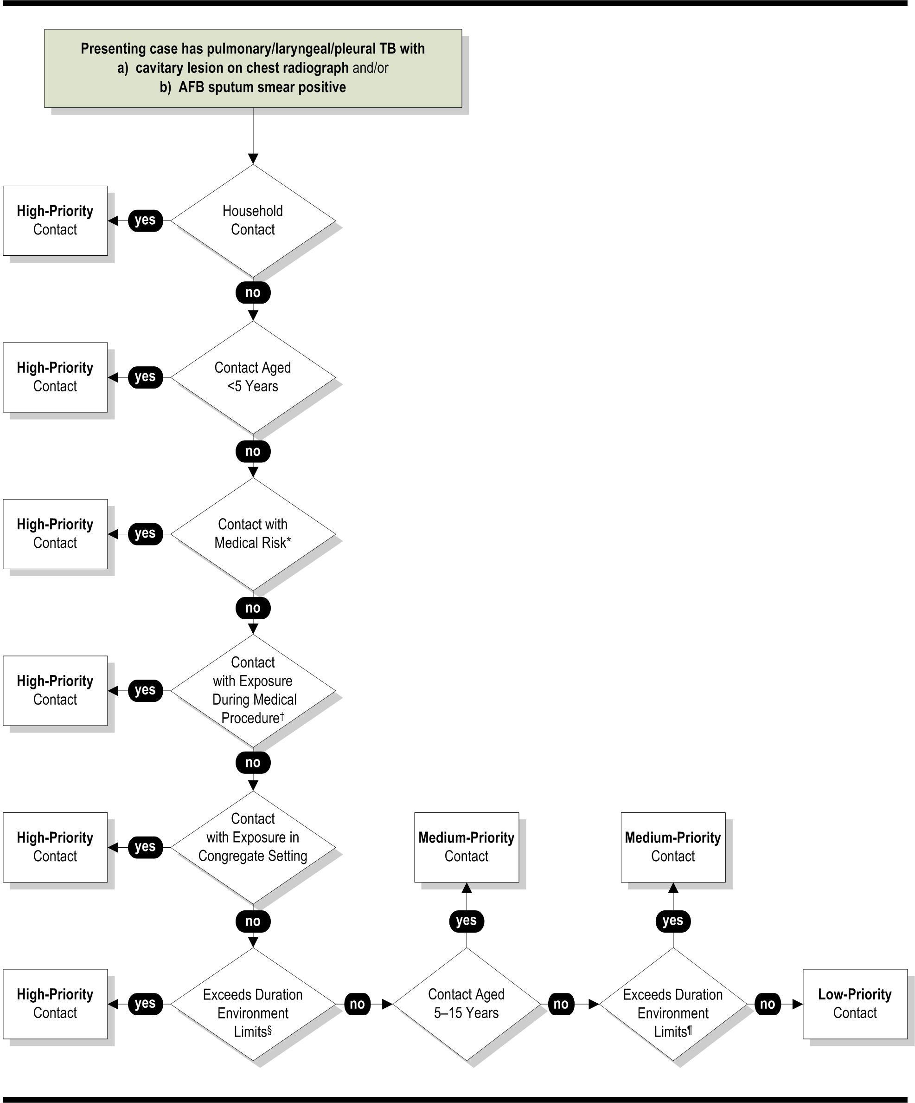
Definition of abbreviations: AFB = acid-fast bacilli; HIV = human immunodeficiency virus.
* HIV or other medical risk factor.
† Bronchoscopy, sputum induction, or autopsy.
§ Exposure exceeds duration/environment limits per unit time established by the health department for high-priority contacts.
¶ Exposure exceeds duration/environment limits per unit time established by the health department for medium-priority contacts.
Source: CDC. Guidelines for the investigation of contacts of persons with infectious tuberculosis: recommendations from the National Tuberculosis Controllers Association and CDC. MMWR 2005;54(No. RR-15):12.
<<If the Figure 2 algorithm is not easy to use, use Table 6 to assign priorities. Note the exposure durations/limits for high-priority and medium-priority contacts established by your state program.>>
Table 6: Prioritization of Contacts to Smear-Positive or Cavitary Cases
High-Priority Contacts | Medium-Priority Contacts | Low-Priority Contacts
- Household contacts  - Contacts <5 years old  - Contacts with human immunodeficiency virus (HIV) infection or other immunocompromising condition  - Contacts with exposure during a medical procedure such as bronchoscopy, sputum induction, or autopsy  - Contacts with exposure in a congregate setting  - Contacts whose exposure exceeds duration/environment limits per unit time established by the health department for high-priority contacts: <<Describe exposure limits.>> | - Contacts not in high-priority groups  - Contacts 5–15 years old  - Contacts whose exposure exceeds duration/environment limits per unit time established by the health department for medium-priority contacts: <<Describe exposure limits.>> | - Contacts not in high-priority groups  - Contacts not in medium-priority groups
Source: CDC. Guidelines for the investigation of contacts of persons with infectious tuberculosis: recommendations from the National Tuberculosis Controllers Association and CDC. MMWR 2005;54 (No. RR-15):12.

Index Patient with Negative Acid-Fast Bacilli Sputum Smear Results
Use <<Figure 3 or Table 7>> to prioritize contacts to smear-negative index patients. <<Note the exposure durations/limits for medium-priority established by your state program.>>
Figure 3: Prioritization of Contacts to Smear-Negative Cases
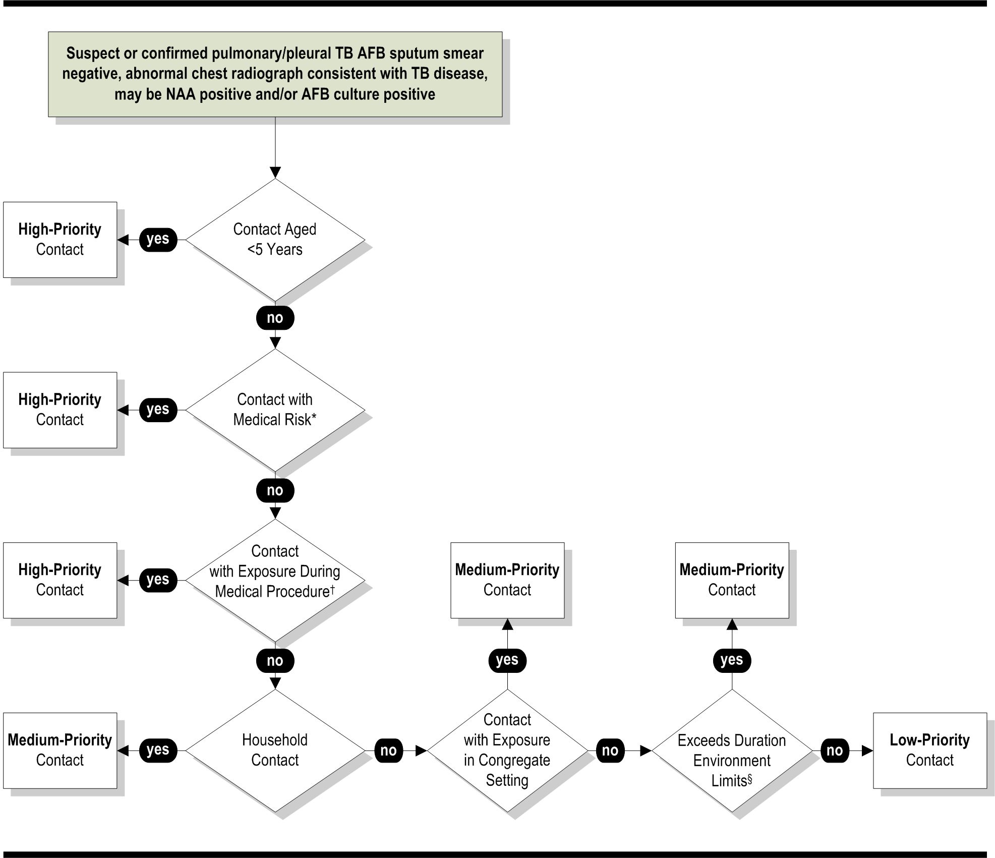

Definition of abbreviations: AFB = acid-fast bacilli; HIV = human immunodeficiency virus; NAA = nucleic acid assay.
* HIV or other medical risk factor.
† Bronchoscopy, sputum induction, or autopsy.
§ Exposure exceeds duration/environment limits per unit time established by the local TB control program for medium-priority contacts.
Source: CDC. Guidelines for the investigation of contacts of persons with infectious tuberculosis: recommendations from the National Tuberculosis Controllers Association and CDC. MMWR 2005;54(No. RR-15):13.
<<If Figure 3 is not easy to use, use Table 7 to assign contacts priorities.>>
Use Table 7 to prioritize contacts to smear-negative index patients.
Table 7: Prioritization of Contacts to Smear-Negative Cases
High-Priority Contacts | Medium-Priority Contacts | Low-Priority Contacts
- Contacts <5 years old  - Contacts with human immunodeficiency virus (HIV) infection or other immunocompromising conditions  - Contacts exposed during a medical procedure such as bronchoscopy, sputum induction, or autopsy | - Contacts not in high-priority groups  - Household contacts  - Contacts exposed in a congregate setting  - Contacts whose exposure exceeds duration/environment limits per unit time established by the local TB control program for medium-priority contacts <<Describe exposure limits.>> | - Contacts not in high-priority groups  - Contacts not in medium-priority groups
Source: CDC. Guidelines for the investigation of contacts of persons with infectious tuberculosis: recommendations from the National Tuberculosis Controllers Association and CDC. MMWR 2005;54(No. RR-15):13.

Index Patient with Negative Bacteriologic Results and Abnormal Chest Radiographs not Consistent with Tuberculosis
Use Table 8 to prioritize contacts to a suspected case of pulmonary TB who is acid-fast bacilli (AFB) sputum smear negative, who is nucleic acid amplification (NAA) negative and culture negative, and who has abnormal chest radiographs not consistent with TB disease.
Table 8: Prioritization of Contacts to Cases with Negative Bacteriologic results and abnormal chest radiographs not consistent with tuberculosis
High-Priority Contacts | Medium-Priority Contacts | Low-Priority Contacts
 | - Household contacts  - Contacts <5 years old  - Contacts with human immunodeficiency virus (HIV) infection or other medical risk factor  - Contacts exposed during a medical procedure such as bronchoscopy, sputum induction, or autopsy | - Contacts not in medium-priority groups
Source: CDC. Guidelines for the investigation of contacts of persons with infectious tuberculosis: recommendations from the National Tuberculosis Controllers Association and CDC. MMWR 2005;54(No. RR-15):14.

Contact Evaluation, Treatment, and
Follow-up
Complete evaluation, treatment, and follow-up for high- and medium-priority contacts, as specified in your contact investigation plan. The Centers for Disease Control and Prevention (CDC) recommends the following:
- Provide each high- and medium-priority contact an initial assessment that includes a face-to-face encounter in which an impression of each contact’s general health is formed and a tuberculin skin test (TST) is usually administered.
- Medically evaluate each high- and medium-priority contact to determine whether tuberculosis (TB) disease or latent tuberculosis infection (LTBI) is present or absent.
- Timely initiation of treatment is especially important for high-priority contacts and for contacts likely to progress to TB disease if they are infected (i.e., susceptible contacts) or contacts who could suffer severe morbidity if they had TB disease (i.e., vulnerable contacts). For recommended time frames, refer to Table 3: Time Frames for Contact Evaluation and Treatment in the “Time Frames for Contact Investigation” topic.
- Use the same diagnostic methods for all contacts, except when they have medical or constitutional conditions making TB more likely or more difficult to diagnose. A contact’s country of origin and bacille Calmette-Guérin (BCG) vaccination are not included in algorithms for diagnosis or treatment. Interpret a positive TST in a foreign-born or BCG-vaccinated person as evidence of recent Mycobacterium tuberculosis infection in contacts of persons with infectious cases. Evaluate these contacts for TB disease and offer them a course of treatment for LTBI.
<<Below are pairs of flowcharts and tables for prioritizing contacts. When customizing the template for your state, choose either the flowcharts (algorithms) or the tables, because using both may confuse your readers. In reviewing the tools, using local experience and adjusting for resource limitations, set local standards for the durations of exposure that define high-, medium-, and low-priority contacts.>>
Use the <<figures or tables>> on the following pages to determine the evaluation activities for contacts in these different risk groups and priority rankings:
- <<Figure 4 or Table 9>>: Evaluation, Treatment, and Follow-Up of Immunocompromised Contacts and Children Under Five Years Old
- <<Figure 5 or Table 10>>: Evaluation, Treatment, and Follow-Up of Immunocompetent Adults and Children Five and Older (High- and Medium-Priority Contacts)
- <<Figure 6 or Table 11>>: Evaluation, Treatment, and Follow-Up of Contacts with Prior Positive Tuberculin Skin Tests
During contact evaluation, treatment, and follow-up, use the <<form name>> available from << Web page name>> at << Web page address>>.

For time frames, see the “Time Frames for Contact Investigation” topic in this section. To arrange follow-up with public health officials in other jurisdictions for out-of-area contacts, see the Transfer Notifications section.

Immunocompromised Contacts and Children under Five
Use <<Figure 4 or Table 9>> to select evaluation, treatment, and follow-up activities for contacts who are immunocompromised and/or under five years old.
Figure 4: Evaluation, Treatment, and Follow-up of Immunocompromised Contacts and Children under Five years old
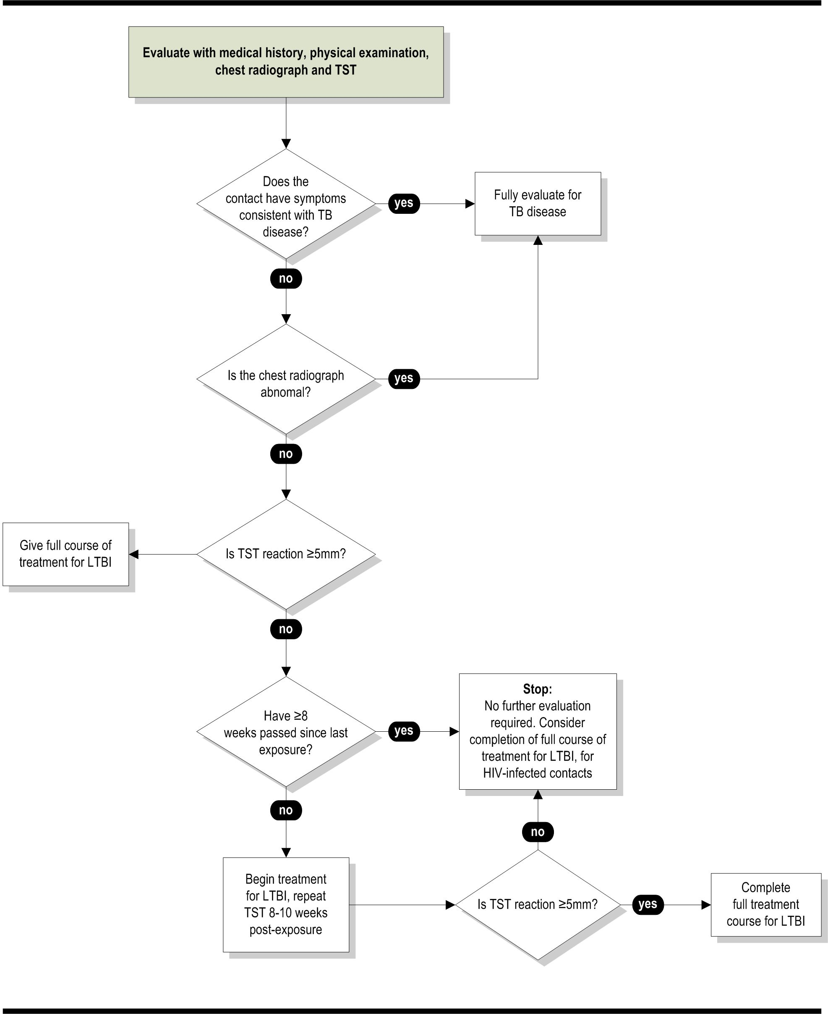
Definition of abbreviations: HIV = human immunodeficiency virus; IGRA = interferon gamma release assay; LTBI = latent tuberculosis infection; TST = tuberculin skin test.
Note: An IGRA may be used in place of a TST.
Source: CDC. Guidelines for the investigation of contacts of persons with infectious tuberculosis; recommendations from the National Tuberculosis Controllers Association and CDC, and guidelines for using the QuantiFERON®-TB Gold test for detecting Mycobacterium tuberculosis infection, United States. MMWR 2005;54(No. RR-15):15.

<<If Figure 4 is not easy to use, use Table 9.>> Evaluate contacts who are immunocompromised or under five years of age with medical history, physical examination, chest radiograph, and tuberculin skin test (TST) or interferon gamma release assay (IGRA). Based on the results of these evaluations, take the actions in Table 9.
Timely initiation of treatment is especially important for these contacts. Refer to Table 3: Time Frames for Contact Evaluation and Treatment in the “Time Frames for Contact Investigation” topic.

Table 9: Evaluation, Treatment, and Follow-up of Immunocompromised Contacts and Children under Five years old
If evaluation or test results show that  a contact has the following: |  | Then take this action or these actions:
Symptoms consistent with TB disease  and/or  Abnormal chest radiograph |  | Fully evaluate for TB disease
No symptoms consistent with TB disease and  normal chest radiographs | 1st TST* ≥5 mm | Complete a full course of treatment for LTBI
 | 1st TST <5 mm  and  ≥8 weeks since last exposure | - If not HIV-infected, no further evaluation required  - If HIV-infected, no further evaluation required; consider a full course of treatment for LTBI
 | 1st TST <5 mm  and  <8 weeks since last exposure | Begin treatment for LTBI and retest 8–10 weeks post exposure
 | 2nd TST ≥5 mm | Complete a full course of treatment for LTBI
 | 2nd TST <5 mm | - If not HIV-infected, no further evaluation required  - If HIV-infected, no further evaluation required; consider a full course of treatment for LTBI
Definitions of abbreviations: HIV = human immunodeficiency virus; IGRA = interferon gamma release assay; LTBI = latent tuberculosis infection; TB = tuberculosis; TST = tuberculin skin test.
* Note: An IGRA may be used in place of a TST.
Source: CDC. Guidelines for the investigation of contacts of persons with infectious tuberculosis: recommendations from the National Tuberculosis Controllers Association and CDC, and guidelines for using the QuantiFERON®-TB Gold test for detecting Mycobacterium tuberculosis infection, United States. MMWR 2005;54(No. RR-15):15–16.

Immunocompetent Adults and Children Five and Older
(High- and Medium-Priority Contacts)
Use <<Figure 5 or Table 10>> to select evaluation, treatment, and follow-up activities for high- and medium-priority contacts who are immunocompetent and/or five years of age or older.
Figure 5: Evaluation, Treatment, and Follow-up of Immunocompetent Adults and Children five years or older (High- and Medium-Priority Contacts)
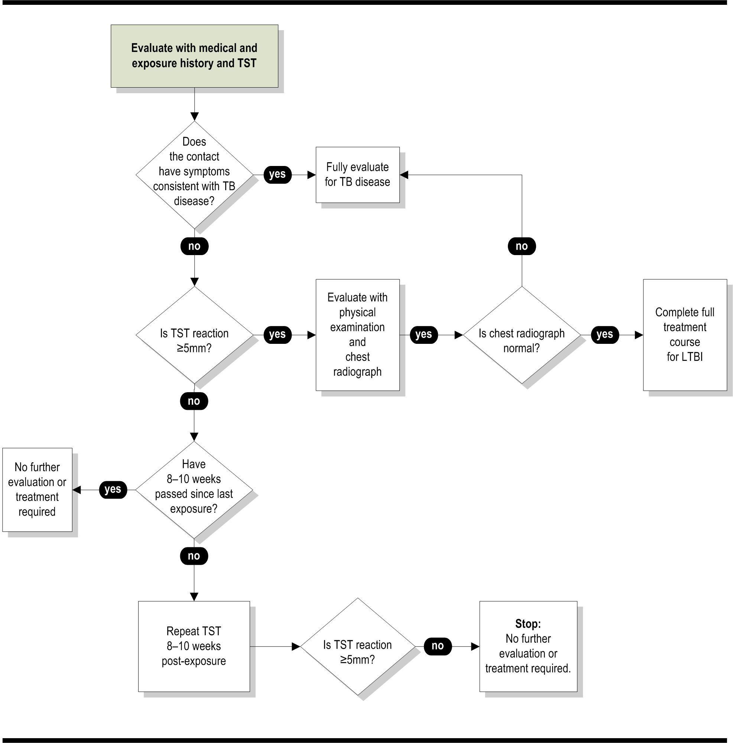
Definition of abbreviations: IGRA = interferon gamma release assay; LTBI = latent tuberculosis infection;
TST = tuberculin skin test.
Note: An IGRA may be used in place of a TST.
Source: CDC. Guidelines for the investigation of contacts of persons with infectious tuberculosis; recommendations from the National Tuberculosis Controllers Association and CDC, and guidelines for using the QuantiFERON®-TB Gold test for detecting Mycobacterium tuberculosis infection, United States. MMWR 2005;54(No. RR-15):17.

<<If Figure 5 is not easy to use, use Table 10.>>
Evaluate high- and medium-priority contacts who are immunocompetent and/or five years of age or older, with medical history, exposure history, and tuberculin skin test (TST) or interferon gamma release assay (IGRA). Based on the results of these evaluations, take the actions in Table 10.
Table 10: Evaluation, Treatment, and Follow-up of Immunocompetent Adults and Children Five years and older (High- and Medium-Priority Contacts)
If evaluation or test results show that a contact has the following: |  | Then take this action or these actions:
Symptoms consistent with TB disease |  | Fully evaluate for TB disease
No symptoms consistent with TB disease | 1st TST* ≥5 mm | Evaluate with a physical examination and CXR:  - If CXR abnormal, fully evaluate for TB disease  - If CXR normal, complete a full course of treatment for LTBI
No symptoms consistent with TB disease | 1st TST <5 mm  and  8–10 weeks since last exposure | No further evaluation or treatment required
No symptoms consistent with TB disease | 1st TST <5 mm  and  <8 weeks since last exposure | Retest 8–10 weeks post exposure
No symptoms consistent with TB disease | 2nd TST ≥5 mm | Evaluate with a physical examination and CXR:  - If CXR abnormal, fully evaluate for TB disease  - If CXR normal, complete a full course of treatment for LTBI
No symptoms consistent with TB disease | 2nd TST <5 mm | No further evaluation or treatment required
Definitions of abbreviations: CXR = chest radiograph; IGRA = interferon gamma release assay; LTBI = latent tuberculosis infection; TB = tuberculosis; TST = tuberculin skin test.
* Note: An IGRA may be used in place of a TST.
Source: CDC. Guidelines for the investigation of contacts of persons with infectious tuberculosis: recommendations from the National Tuberculosis Controllers Association and CDC, and guidelines for using the QuantiFERON®-TB Gold test for detecting Mycobacterium tuberculosis infection, United States. MMWR 2005;54(No. RR-15):17.

Contacts with Prior Positive Tuberculin Skin Tests
Use <<Figure 6 or Table 11>> to select evaluation, treatment, and follow-up activities for contacts who have prior positive TSTs.
Figure 6: Evaluation, Treatment, and Follow-up of Contacts with Prior Positive TUBERCULIN SKIN TESTS
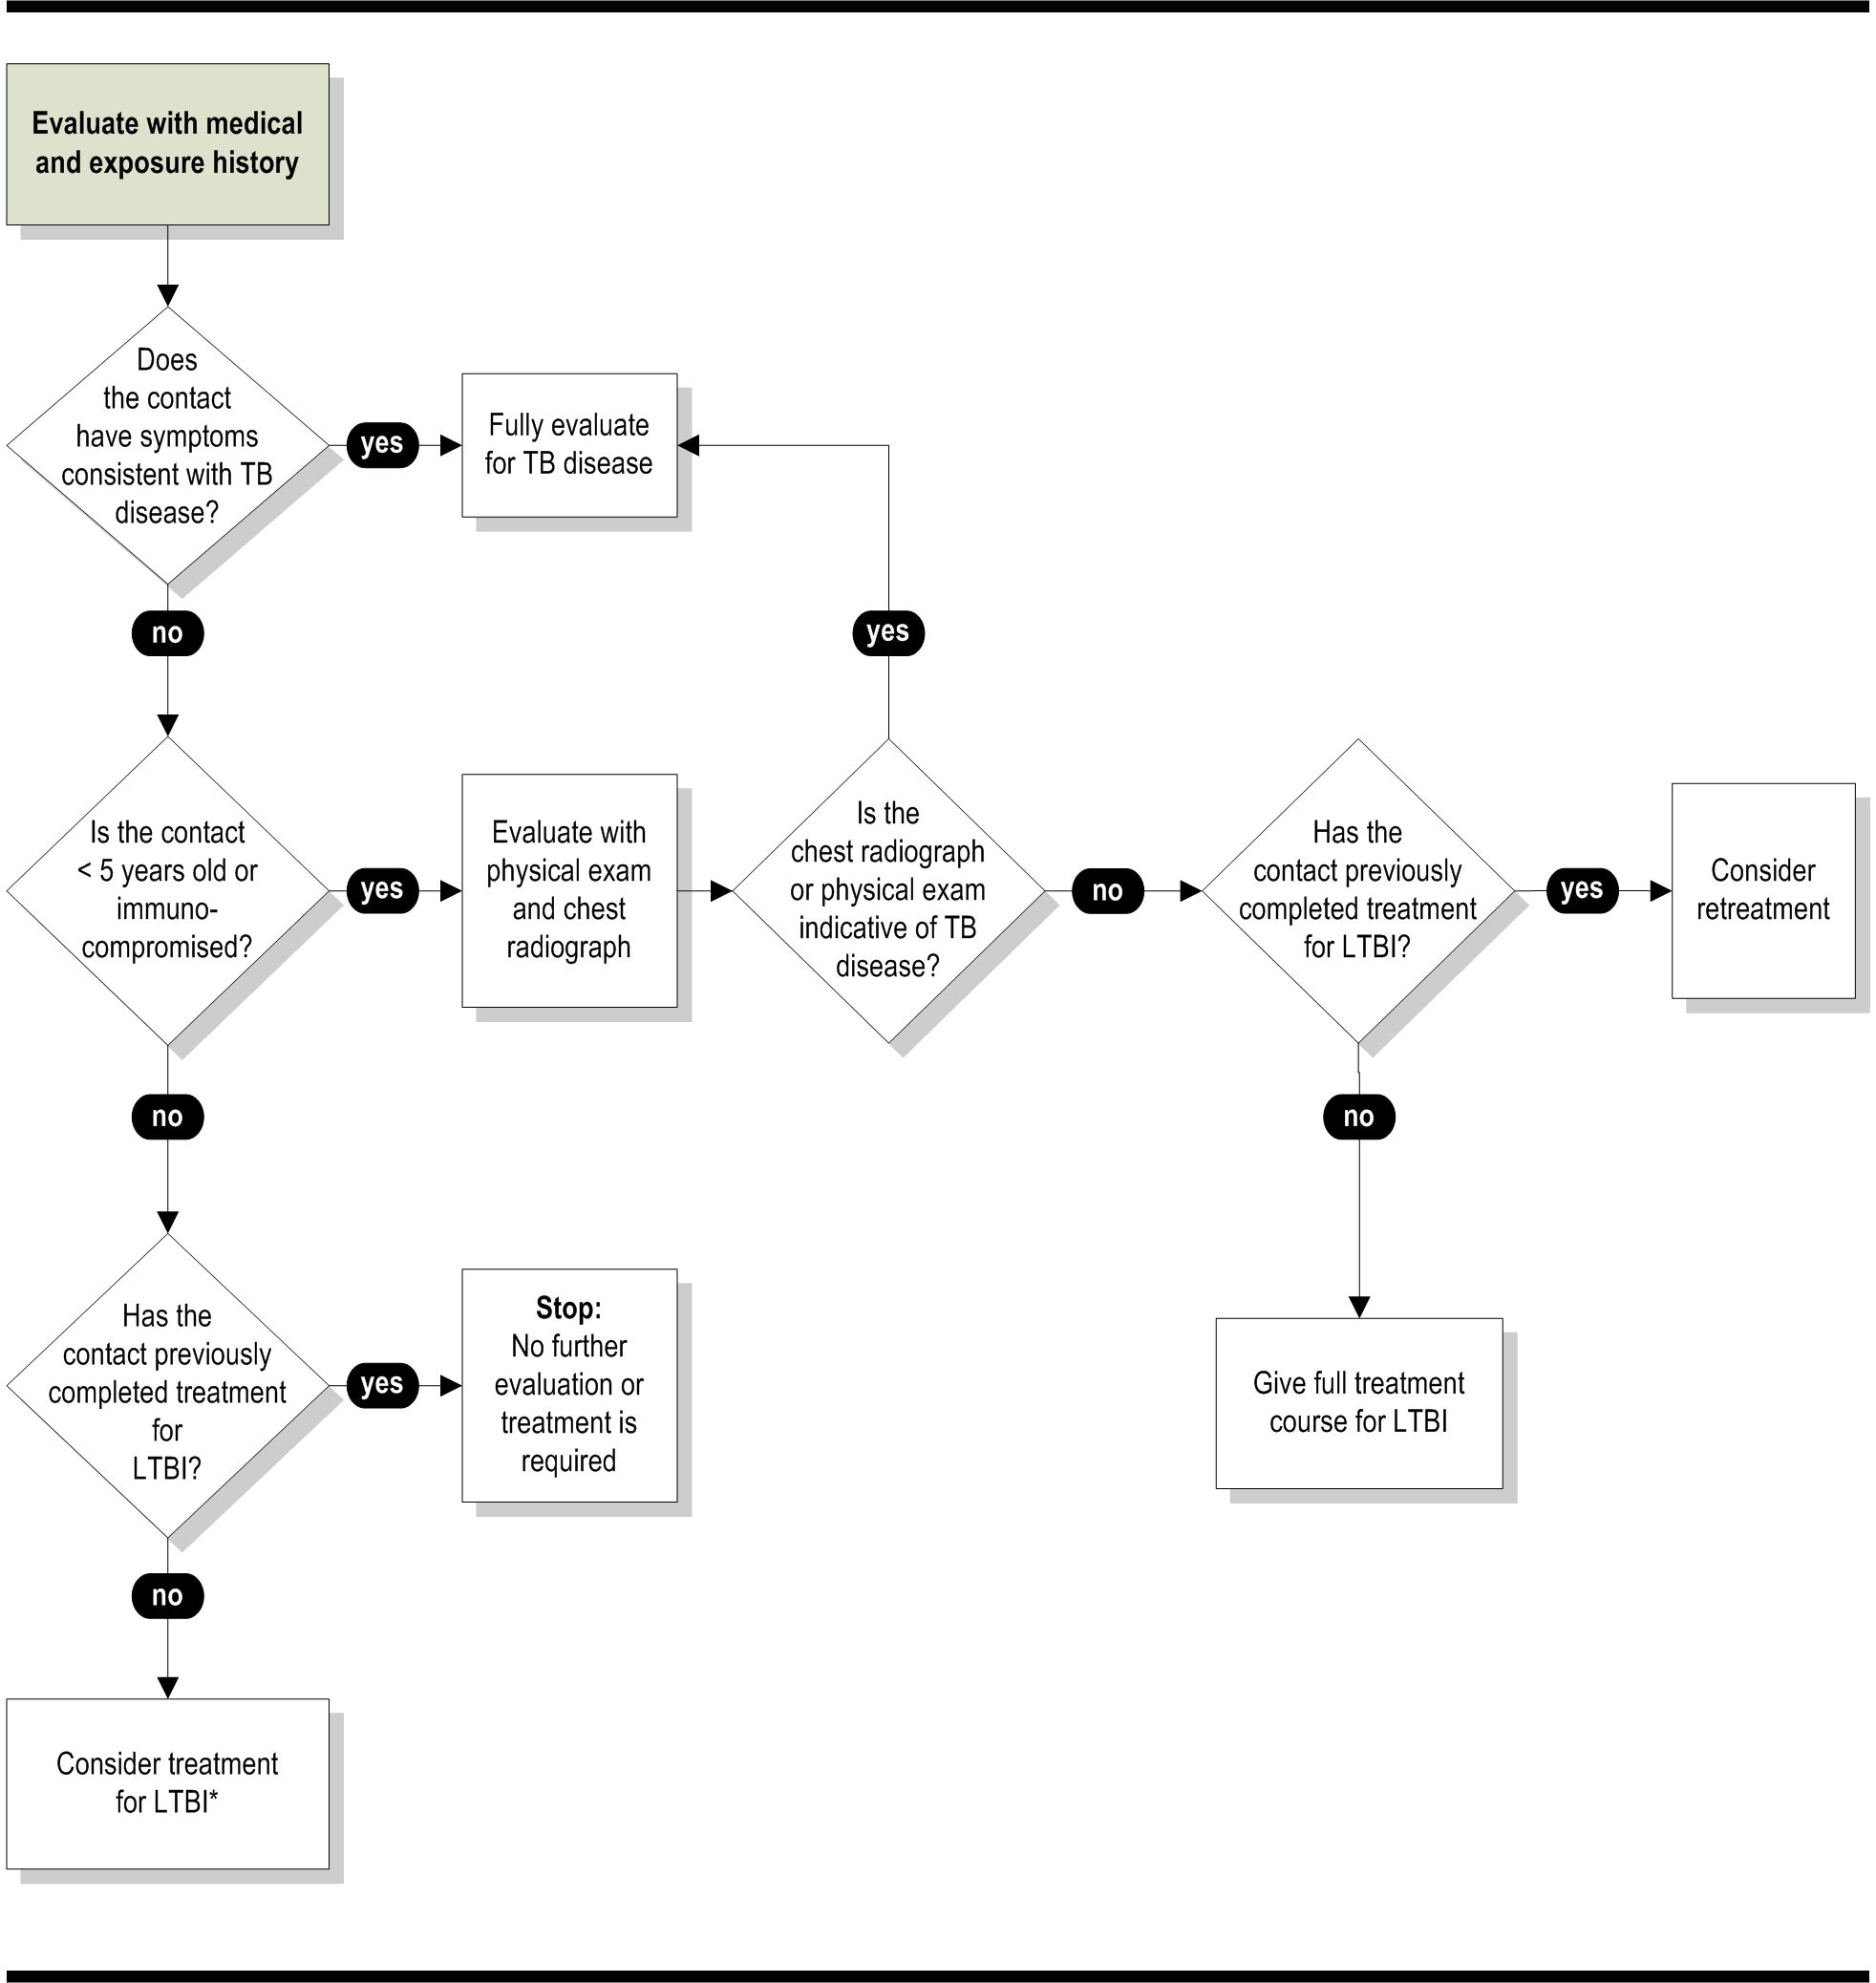
Definition of abbreviations: HIV = human immunodeficiency virus; LTBI = latent tuberculosis infection.
* Before initiation of treatment, contacts should be evaluated fully for TB disease. A full course treatment is recommended for HIV-infected contacts in this category.

Source: CDC. Guidelines for the investigation of contacts of persons with infectious tuberculosis; recommendations from the National Tuberculosis Controllers Association and CDC, and guidelines for using the QuantiFERON®-TB Gold test for detecting Mycobacterium tuberculosis infection, United States. MMWR 2005;54(No. RR-15):19.
<<If Figure 6 is not easy to use, use Table 11.>>
For contacts with prior positive TSTs, evaluate them with medical and exposure history. Based on these histories, take the actions in Table 11.
Table 11: Evaluation, Treatment, and Follow-up of Contacts with Prior Positive Tuberculin Skin Tests
If evaluation or test results show that a contact has the following: |  | Then take this action or these actions:
Symptoms consistent with TB disease |  | Fully evaluate for TB disease
No symptoms consistent with TB disease | Immunocompromised  or  <5 years old | Evaluate with a physical examination and CXR:  - If CXR or physical examination is indicative of TB disease, fully evaluate for TB disease  - If results are not indicative of TB disease:  - If contact previously completed treatment, consider retreatment  - If treatment not completed previously, complete a full course of LTBI treatment
No symptoms consistent with TB disease | Immunocompetent  and  ≥5 years old | - If contact previously completed treatment for LTBI, no further evaluation or treatment required  - If contact has not completed treatment for LTBI, consider treatment for LTBI
Definitions of abbreviations: CXR = chest radiograph; LTBI = latent tuberculosis infection; TB = tuberculosis.
Source: CDC. Guidelines for the investigation of contacts of persons with infectious tuberculosis: recommendations from the National Tuberculosis Controllers Association and CDC, and guidelines for using the QuantiFERON®-TB Gold test for detecting Mycobacterium tuberculosis infection, United States. MMWR 2005;54(No. RR-15):19.

When to Expand a Contact Investigation

Guidelines for Expanding an Investigation
Determine when to expand a contact investigation using the following guidelines:
- Do not include lower-priority contacts unless objectives for high- and medium-priority contacts are being met.
- Consider the extent of recent transmission.
- Consider expanding the scope (e.g., number of contacts) of an investigation if any one or more of the following criteria are met:
  - Unexpectedly large rate of tuberculosis (TB) infection or disease in high-priority contacts: <<percentage rate>>, or at least twice the rate of a similar population without recent exposure, whichever is greater
<<In general, national guidelines have arbitrarily defined an unexpectedly large rate as 10% or at least twice the rate of a similar population without recent exposure, whichever is greater. Programs should use their own data, if available.>>
Since the background prevalence of tuberculosis infection in adult foreign-born populations from high-incidence countries often exceeds 30%, it is important to stratify the infection rates by country of birth and/or length of residence and by age. For example, household contacts with a positive tuberculin skin test (TST) results are more likely to be infected recently (or as a result of exposure to the index patient) if the contacts are US-born children rather than adults born in high-incidence countries.
  - Evidence of second-generation transmission (i.e., from TB patients who were infected after exposure to the source patient)
  - TB disease in any contacts who had been assigned low priority
  - Infection in any contacts younger than five years old
  - Contacts with change in TST status from negative to positive
- When results from an investigation indicate that it should be expanded, but resources are insufficient, seek assistance from the next higher public health administrative level.
In general, without evidence of recent transmission, do not expand an investigation to lower-priority contacts. When program evaluation objectives have not been met, expand a contact investigation only in exceptional circumstances, generally involving highly infectious cases with high rates of infection among contacts or evidence for secondary cases and secondary transmission. Derive the strategy for expanding an investigation
from the data obtained from the investigation to that point in time. Without data from the initial contact investigation to support evidence of transmission, there is little support to expand to lower-priority contacts. As in the initial investigation, review the incoming results of the expanded investigation at least weekly to reassess the strategy.
Sometimes the result from an investigation indicates a need for expansion, but resources do not permit this. In these situations, seek consultation and assistance from the next higher level in public health administration (e.g., the county health department consults with the state health department). Consultation offers an objective review of strategy and results, additional expertise, and the potential for personnel or funds for meeting unmet needs.
 | Contact <<position>> at <<telephone number>> to consult about expanding a contact investigation.
 | Record your decision and rationale for expanding a contact investigation on <<form name>>.

Low-Priority Contacts
Use <<Figure 7 or Table 12>> to select evaluation, treatment, and follow-up activities for low-priority contacts.
Figure 7: Evaluation, Treatment, and Follow-up of
Low-Priority Contacts
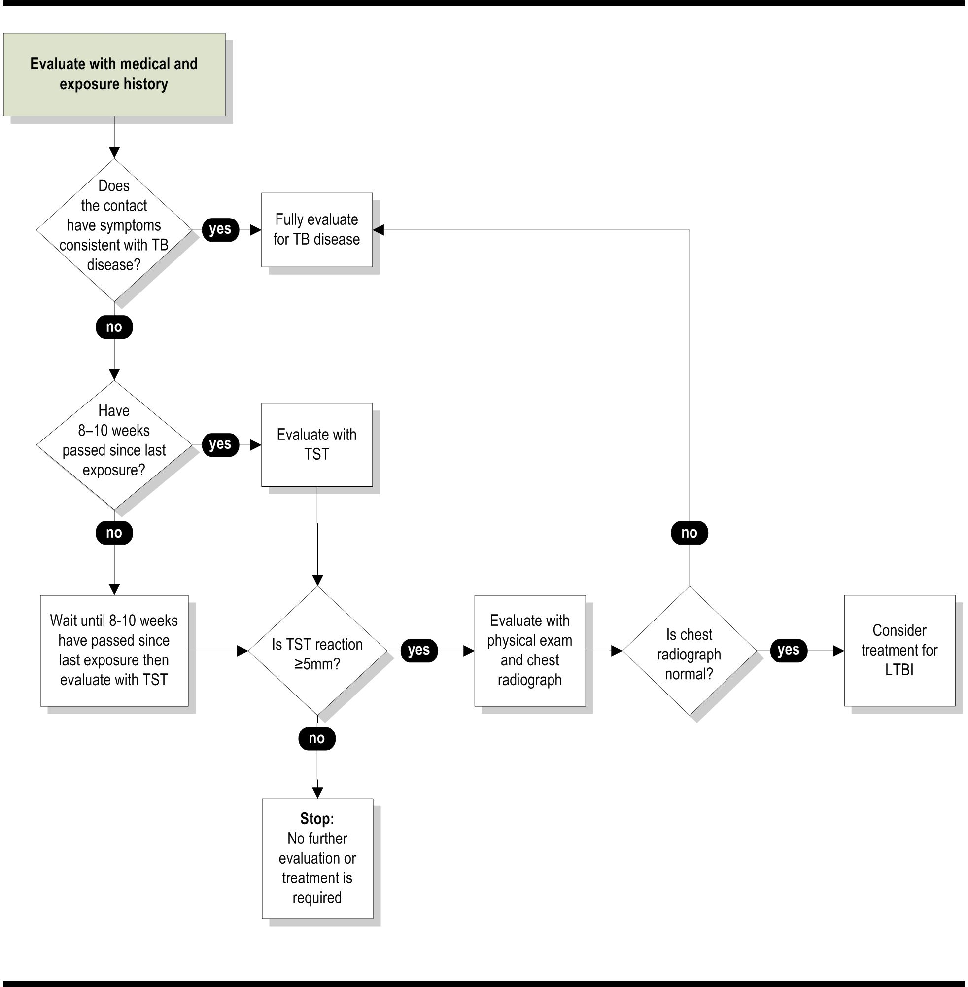
Definition of abbreviations: CXR = chest radiograph; IGRA = interferon gamma release assay; LTBI = latent tuberculosis infection; TST = tuberculin skin test.
* Note: An IGRA may be used in place of a TST.
Source: CDC. Guidelines for the investigation of contacts of persons with infectious tuberculosis; recommendations from the National Tuberculosis Controllers Association and CDC, and guidelines for using the QuantiFERON®-TB Gold test for detecting Mycobacterium tuberculosis infection, United States. MMWR 2005;54(No. RR-15):18.
<<If Figure 7 is not easy to use, use Table 12.>>
Evaluate low-priority contacts with medical and exposure history. Based on these histories, take the actions in the Table 12.
Table 12: Evaluation, Treatment, and Follow-up of
Low-Priority Contacts
If evaluation or test results show that a contact has the following: |  |  | Then take this action or these actions:
Symptoms consistent with TB disease |  | Fully evaluate for TB disease
No symptoms consistent with TB disease | 8–10 weeks since last exposure | Evaluate with a TST
No symptoms consistent with TB disease | <8 weeks since last exposure | Wait 8–10 weeks after last exposure, and then evaluate with a TST
No symptoms consistent with TB disease | 1st TST* ≥5 mm | Evaluate with physical examination and CXR:  - If CXR is abnormal, fully evaluate for TB disease  - If CXR is normal, consider treatment for LTBI
No symptoms consistent with TB disease | 1st TST <5 mm | No further evaluation or treatment required
Definitions of abbreviations: CXR = chest radiograph; IGRA = interferon gamma release assay; LTBI = latent tuberculosis infection; TB = tuberculosis; TST = tuberculin skin test.
* Note: An IGRA may be used in place of a TST.
Source: CDC. Guidelines for the investigation of contacts of persons with infectious tuberculosis: recommendations from the National Tuberculosis Controllers Association and CDC, and guidelines for using the QuantiFERON®-TB Gold test for detecting Mycobacterium tuberculosis infection, United States. MMWR 2005;54(No. RR-15):22.

Data Management and Evaluation of Contact Investigations
Data collection related to contact investigations has three broad purposes:
- Management of care and follow-up of individual index patients and contacts
- Epidemiologic analysis of an investigation in progress as well as overall results of previous investigations
- Program evaluation via performance indicators that reflect performance objectives

Reasons Contact Investigation Data Are Needed

Comprehensive Care
For each index patient and the associated contacts, a broad amount of demographic, epidemiologic, historical, and medical information is needed for providing comprehensive care. The care for these individuals can extend to longer than a year in some instances, so the information builds stepwise and has numerous longitudinal elements (e.g., clinic visits attended, treatment doses administered, and bacteriologic response to treatment).

Timeline Objectives
Many of these data elements also contribute to the other reasons for collecting data. Data on some process steps are necessary for monitoring whether the contact investigation is keeping to the timeline objectives (e.g., how soon after listing is the tuberculin skin test (TST) administered to a contact).

Completion of Investigation
When aggregated, the data from an investigation inform public health officials as to whether the investigation is on time and complete. The analysis of data also contributes to reassessments of the strategy used in the investigation (e.g., was the infection rate greater for contacts believed to have more exposure?).

Reassessment of Strategy
The data from a completed investigation and all investigations in a fixed period (e.g., six months) show achievements in meeting program objectives, such as observance of timelines and completion of therapy for infected contacts. These core measurements for program evaluation, however, cannot directly show why objectives were not met. If the data are structured and stored in formats allowing detailed retrospective review, then the reasons for problems can be studied.
To assess the overall activities of contact investigations, see the CDC’s “Framework of Program Evaluation in Public Health” (MMWR 1999;48[No. RR-11]) at this hyperlink: ftp://ftp.cdc.gov/pub/Publications/mmwr/rr/rr4811.pdf.

Approach
Follow a systematic, consistent approach to data collection, organization, analysis, and dissemination.
<<Below are CDC recommendations for data collection, organization, analysis, and dissemination. Revise these recommendations to reflect your state’s practice. Indicate which agencies and positions should perform each activity in your state’s list.>>
- Collect specific data elements on index patients and their contacts. The data elements should permit calculation of program performance indices.
- Collect data on standardized (paper or electronic) forms.
- Supply data definitions and formats for use by persons who collect, use, and interpret contact investigation data.
- Whenever feasible, use data definitions and formats that are standard among jurisdictions.
- Store data electronically for quick analysis of interim results.
- Implement policies for data management that enable quick analysis of interim results.
- Implement policies for data management and storage that specify the assignment of responsibilities.
- Implement training and policies for data accuracy, completeness, and security.
- Periodically summarize and review data during a particular contact investigation and for overall contact investigations.
- Evaluate programs for contact investigation activities at least annually. Evaluation is an integral part of TB program responsibility.
- Beyond standard data elements shown in these guidelines, specific additional elements can contribute to local program management.

Index Patient and Contact Data
Use the <<form name>> to collect the data for each index patient and the <<form name>> to collect the data on individual contacts.

< Table 13 lists data recommended by the Centers for Disease Control and Prevention (CDC). This table is provided to assist you in creating a form. Refer to this table to select the data elements that reflect your state’s regulations and practices and your program’s needs in tracking progress toward objectives and in reporting to the CDC. Delete Table 13 after you’ve created your form.>>
Table 13: Data about the Index Patient
Identifiers/Demographic Information | - Case manager  - Name and aliases  - For minors and dependents: guardian information  - Date of birth  - Social security number  - Current locating information and emergency contacts  - Residences during infectious period if unstably housed  - Sex  - Race  - Ethnicity  - Country of birth  - Time in United States, if foreign born  - Primary language and preferred language  - Methods of translation or interpretation
Transmission Settings and Associated Time Frames | - Living situation(s)  - Employment or school  - Social/recreational activities  - Congregate settings (e.g., jail, homeless shelter)  - Substance abuse with social implications (e.g., crack cocaine)
Tuberculosis Information | - Healthcare provider for TB (e.g., public health, private, both, other)  - Anatomic site of disease  - Symptoms and their dates  - CXR results, presence of cavity  - TB medications with start and stop dates  - Bacteriologic results (sputum smear, culture, drug susceptibility) with dates  - Previous history of TB disease and treatment  - Infectious period (updated as new information arrives)  - HIV infection status  - HIV/AIDS registry number
Contact Investigation | - Date of initial interview with index patient  - Dates of follow-up interviews with index patient
Definitions of abbreviations: AIDS = acquired immunodeficiency syndrome; CXR = chest radiograph; HIV = human immunodeficiency virus; RVCT = Reports of Verified Cases of Tuberculosis; TB = tuberculosis.
Source: CDC. Guidelines for the investigation of contacts of persons with infectious tuberculosis: recommendations from the National Tuberculosis Controllers Association and CDC, and guidelines for using the QuantiFERON®-TB Gold test for detecting Mycobacterium tuberculosis infection, United States. MMWR 2005;54(No. RR-15):21.
<<Table 14 lists data recommended by the Centers for Disease Control and Prevention (CDC). This table is provided to assist you in creating a form. Refer to this table to select the data elements that reflect your state’s regulations and practices and your program’s needs in tracking progress toward objectives and in reporting to the CDC. Delete Table 14 after you’ve created your form.>>
Table 14: Data about Each Contact
Investigator  and Dates | - Contact manager or investigator  - Date listed  - How or why the contact was listed (e.g., named by index patient)  - Dates of interviews  - Start and end dates for exposure (updated as new information arrives)
Identifiers | - Name and aliases  - For minors and dependents: guardian information  - Social security number  - Date of birth  - Locating information and emergency contacts  - Sex  - Race  - Ethnicity  - Country of birth  - Time in the United States, if foreign born  - Primary language and preferred language  - Methods of translation or interpretation
Exposure | - Relationship/connection to the index patient  - Social affiliations (e.g., work, school, church, clubs, activities)  - Environmental information about exposure settings (e.g., size, ventilation)  - Frequency, duration, and time frame of interactions
Medical History  and Risk Factors | - Prior history of TB disease or LTBI, and documentation  - BCG vaccination and date  - Medical risk factors for progression of infection to TB disease†  - Population risk factors for prevalent M. tuberculosis infection†
Evaluation for Tuberculosis Disease and Latent Tuberculosis Infection | - Healthcare provider for TB (e.g., public health, private, both, other)  - Symptoms suggesting TB disease  - TSTs, with dates, reagents and lot numbers, reaction measurement  - IGRA results  - CXR results with dates  - Bacteriologic results with dates  - HIV infection status  - Final diagnostic classifications for LTBI or TB disease
Treatment Information for Contacts with Latent Tuberculosis Infection | - Dates of treatment  - Treatment regimen (medications, dosing schedule, any changes to these)  - Methods of supervising treatment (DOT, etc.)  - Adverse reactions (specify each)  - Interruptions in regimen and dates  - Outcome of treatment (completion, etc., consistent with ARPE†)  - If treatment not completed, reason†
Definitions of abbreviations: ARPE = Aggregate Report for Program Evaluation; BCG = bacille Calmette-Guérin; CXR = chest radiograph; DOT = directly observed therapy; HIV = human immunodeficiency virus; IGRA = interferon gamma release assay; LTBI = latent tuberculosis infection; TB = tuberculosis; TST = tuberculin skin test.
† As defined by CDC ARPE for contact investigations.
Source: CDC. Guidelines for the investigation of contacts of persons with infectious tuberculosis: recommendations from the National Tuberculosis Controllers Association and CDC, and guidelines for using the QuantiFERON®-TB Gold test for detecting Mycobacterium tuberculosis infection, United States. MMWR 2005;54(No. RR-15):21.

Evaluation of a Contact Investigation
Summarize the results of a contact investigation to report by priority the total number of contacts who were identified, were tested, started therapy, and completed therapy.
< | Record your summary on <<form name>> available from <<Web page>> at <<Web address>>.
<<Describe your state’s general process for completing APRE form.>>
In addition, the CDC’s Framework for Program Evaluation in Public Health is recommended for assessing the overall activities of contact investigations.
For information about the ARPE form, see the CDC’s Aggregate Reports for Tuberculosis Program Evaluation: Training Manual and User’s Guide. (Atlanta, GA: US Department of Health and Human Services, CDC; 2005) at this hyperlink: http://www.cdc.gov/tb/pubs/PDF/ARPEs_manual.pdf .
For more information on using this evaluation framework, see the CDC Program Evaluation Workgroup’s Web site at this hyperlink: http://www.cdc.gov/eval/framework.htm .

Outbreak Investigation
If data from a contact investigation or surveillance indicate a potential outbreak, conduct an outbreak investigation. A tuberculosis (TB) outbreak warns of potential extensive transmission. An outbreak implies that (1) a TB patient was contagious, (2) contacts were exposed significantly, and (3) the interval since exposure has been sufficient for infection to progress to disease. An outbreak investigation involves several overlapping contact investigations, with a surge in the need for public health resources. More emphasis on active case finding is recommended, which sometimes means that more contacts than usual should have chest radiographs and specimen collection for mycobacteriology.

Definition of a Tuberculosis Outbreak
Definitions for TB outbreak are relative to the local context. Outbreak cases can be distinguished from other cases only when certain associations in time, location, patient characteristics, or Mycobacterium tuberculosis attributes (e.g., drug resistance or genotype) become apparent. In low-incidence jurisdictions, any temporal cluster is suspicious for an outbreak. A working definition of a potential TB outbreak is helpful for planning and response, and may include any of the following six criteria:
Criteria based on surveillance and epidemiology:
- An increase has occurred above the expected number of TB cases.
- During and because of a contact investigation, two or more contacts are identified as having TB disease, regardless of their assigned priority (i.e., high, medium, or low priority).
- Any two or more cases occurring within one year of each other are discovered to be linked, and the linkage is established outside of a contact investigation (e.g., two patients who received a diagnosis of TB disease outside of a contact investigation are found to work in the same office and only one or neither of the persons was listed as a contact to the other).
- A genotype cluster leads to discovery of one or more verified transmission links that were missed during a contact investigation within the prior two years.
Criteria based on program resources:
- Transmission is continuing despite adequate control efforts by the TB control program.
- Contact investigation associated with increased cases requires additional outside help.

Deoxyribonucleic Acid Genotyping
Deoxyribonucleic acid (DNA) genotyping is a laboratory technique used by public health officials during a TB outbreak to distinguish between different strains of M. tuberculosis and to help assess the likelihood of TB transmission. Characterization of M. tuberculosis with DNA genotyping is a powerful tool for the following:
- Surveillance of potential outbreaks
- Confirming TB cases linked by traditional epidemiologic methods
- Identifying clusters of patients infected with genetically related or identical strains of M. tuberculosis and determining common sources of infections
- Guiding contact investigations and the appropriate use of preventive therapy
- Identifying laboratory cross-contamination as the cause of misdiagnosis
When used to track the transmission of a specific strain, DNA genotyping can help assess the effectiveness of TB control programs, a particularly useful methodology for areas with low TB incidence as the United States approaches TB elimination.
Confirm the linkage between cases by genotyping results if isolates have been obtained. An outbreak increases the urgency of investigations and will put greater demands on the health department. Therefore, corroborate a suspected linkage between cases by genotyping results before intensifying an investigation. An epidemiologic investigation is required for determining probable transmission linkages even if genotypes match.
Any secondary case that is unexpectedly linked to a known index patient represents a potential failure in the contact investigation; in such cases, reassess the original investigation to determine whether the strategy for finding contacts was optimal and whether the priorities were valid. If a secondary case occurred because treatment for a known contact with latent tuberculosis infection (LTBI) was not started or completed, then review the strategies for treatment and completion.

<<Your State’s>> Tuberculosis Outbreak Response Plan
Use the TB Outbreak Response Plan to ensure adequate and timely response to TB outbreaks through evaluation and management of potential TB transmission in schools, workplaces, or community settings., This plan is a separate document from the <<your state>> TB Manual.
<<Your State>> TB Outbreak Response Plan

Resources and References

Resources

- California Department of Health Services (CDHS)/California Tuberculosis Controllers Association (CTCA). “Contact Investigation Guidelines” (CDHS/CTCA Joint Guidelines; 1998). Available at: http://www.ctca.org/guidelines/IID1contactinvestigation.pdf .
- CDC. Aggregate Reports for Tuberculosis Program Evaluation: Training Manual and User’s Guide (Atlanta, GA; 2005). Available at: http://www.cdc.gov/tb/pubs/PDF/ARPEs_manual.pdf .
- CDC. Effective TB Interviewing for Contact Investigation: Self-Study Modules. (Atlanta, GA; 2006). Available at:
http://www.cdc.gov/tb/pubs/Interviewing/default.htm .
- CDC. “Guidelines for the Investigation of Contacts of Persons with Infectious Tuberculosis: Recommendations from the National Tuberculosis Controllers Association and CDC” (MMWR 2005;54 [No. RR-15]). Available at: http://www.cdc.gov/mmwr/pdf/rr/rr5415.pdf .
- CDC. “Goal II: accelerate the decline“ (CDC’s Response to Ending Neglect: The Elimination of Tuberculosis in the United States). Available at: http://www.cdc.gov/tb/pubs/iom/iomresponse/goal2.htm .
- CDC Evaluation Workgroup. Framework for Program Evaluation (CDC Web site). Available at: http://www.cdc.gov/eval/framework.htm .
- New Jersey Medical School National Tuberculosis Center. Performance Guidelines: A Supervisor’s Guide for the Development and Assessment of TB Field Investigation Skills (New Jersey Medical School Global Tuberculosis Institute Web site; 2004). Available at: http://www.umdnj.edu/globaltb/products/performanceguide.htm .
- New Jersey Medical School National Tuberculosis Center. Performance Guidelines for Contact Investigation: The TB Interview (New Jersey Medical School Global Tuberculosis Institute Web site). Available at: http://www.umdnj.edu/globaltb/products/tbinterview.htm .

References

ATS, CDC, IDSA. Controlling tuberculosis in the United States: recommendations from the American Thoracic Society, CDC, and the Infectious Diseases Society of America. MMWR 2005;54(No. RR-12):35.
ATS, CDC, IDSA. Controlling tuberculosis in the United States: recommendations from the American Thoracic Society, CDC, and the Infectious Diseases Society of America. MMWR 2005;54(No. RR-12):35.
ATS, CDC, IDSA. Controlling tuberculosis in the United States: recommendations from the American Thoracic Society, CDC, and the Infectious Diseases Society of America. MMWR 2005;54(No. RR-12):15.
ATS, CDC, IDSA. Controlling tuberculosis in the United States: recommendations from the American Thoracic Society, CDC, and the Infectious Diseases Society of America. MMWR 2005;54(No. RR-12):3.
ATS, CDC, IDSA. Controlling tuberculosis in the United States: recommendations from the American Thoracic Society, CDC, and the Infectious Diseases Society of America. MMWR 2005;54(No. RR-12):4.
ATS, CDC, IDSA. Controlling tuberculosis in the United States: recommendations from the American Thoracic Society, CDC, and the Infectious Diseases Society of America. MMWR 2005;54(No. RR-12):15.
ATS, CDC, IDSA. Controlling tuberculosis in the United States: recommendations from the American Thoracic Society, CDC, and the Infectious Diseases Society of America. MMWR 2005;54(No. RR-12):17
CDC, NTCA. Guidelines for the investigation of contacts of persons with infectious tuberculosis: recommendations from the National Tuberculosis Controllers Association and CDC, and guidelines for using the QuantiFERON®-TB Gold test for detecting Mycobacterium tuberculosis infection, United States. MMWR 2005;54(No. RR-15):4.
CDC, NTCA. Guidelines for the investigation of contacts of persons with infectious tuberculosis: recommendations from the National Tuberculosis Controllers Association and CDC, and guidelines for using the QuantiFERON®-TB Gold test for detecting Mycobacterium tuberculosis infection, United States. MMWR 2005;54(No. RR-15):5, 6.
CDC. Module 6: contact investigations for tuberculosis. Self-Study Modules on Tuberculosis [Division of Tuberculosis Elimination Web site]. 1999:10. Available at: http://www.phppo.cdc.gov/phtn/tbmodules/Default.htm . Accessed July 11, 2006; CDC, NTCA. Guidelines for the investigation of contacts of persons with infectious tuberculosis: recommendations from the National Tuberculosis Controllers Association and CDC, and guidelines for using the QuantiFERON®-TB Gold test for detecting Mycobacterium tuberculosis infection, United States. MMWR 2005;54(No. RR-15):6.
CDC. Module 6: contact investigations for tuberculosis. Self-Study Modules on Tuberculosis [Division of Tuberculosis Elimination Web site]. 1999:10. Available at: http://www.phppo.cdc.gov/phtn/tbmodules/Default.htm . Accessed July 11, 2006.
CDC, NTCA. Guidelines for the investigation of contacts of persons with infectious tuberculosis: recommendations from the National Tuberculosis Controllers Association and CDC, and guidelines for using the QuantiFERON®-TB Gold test for detecting Mycobacterium tuberculosis infection, United States. MMWR 2005;54(No. RR-15):9.
CDC, NTCA. Guidelines for the investigation of contacts of persons with infectious tuberculosis: recommendations from the National Tuberculosis Controllers Association and CDC, and guidelines for using the QuantiFERON®-TB Gold test for detecting Mycobacterium tuberculosis infection, United States. MMWR 2005;54(No. RR-15):4.
CDC, NTCA. Guidelines for the investigation of contacts of persons with infectious tuberculosis: recommendations from the National Tuberculosis Controllers Association and CDC, and guidelines for using the QuantiFERON®-TB Gold test for detecting Mycobacterium tuberculosis infection, United States. MMWR 2005;54(No. RR-15):4.
CDC, NTCA. Guidelines for the investigation of contacts of persons with infectious tuberculosis: recommendations from the National Tuberculosis Controllers Association and CDC, and guidelines for using the QuantiFERON®-TB Gold test for detecting Mycobacterium tuberculosis infection, United States. MMWR 2005;54(No. RR-15):4.
CDC, NTCA. Guidelines for the investigation of contacts of persons with infectious tuberculosis: recommendations from the National Tuberculosis Controllers Association and CDC, and guidelines for using the QuantiFERON®-TB Gold test for detecting Mycobacterium tuberculosis infection, United States. MMWR 2005;54(No. RR-15):4.
ATS, CDC, IDSA. Controlling tuberculosis in the United States: recommendations from the American Thoracic Society, CDC, and the Infectious Diseases Society of America. MMWR 2005;54(No. RR-12):51.
CDC. Racial/ethnic disparities in diagnoses of HIV/AIDS—33 states, 2001–2004. MMWR 2006;55(No. 5):121–125.
CDC, NTCA. Guidelines for the investigation of contacts of persons with infectious tuberculosis: recommendations from the National Tuberculosis Controllers Association and CDC, and guidelines for using the QuantiFERON®-TB Gold test for detecting Mycobacterium tuberculosis infection, United States. MMWR 2005;54(No. RR-15):5.
CDC, NTCA. Guidelines for the investigation of contacts of persons with infectious tuberculosis: recommendations from the National Tuberculosis Controllers Association and CDC, and guidelines for using the QuantiFERON®-TB Gold test for detecting Mycobacterium tuberculosis infection, United States. MMWR 2005;54(No. RR-15):7–8, 43.
CDC, NTCA. Guidelines for the investigation of contacts of persons with infectious tuberculosis: recommendations from the National Tuberculosis Controllers Association and CDC, and guidelines for using the QuantiFERON®-TB Gold test for detecting Mycobacterium tuberculosis infection, United States. MMWR 2005;54(No. RR-15):9.
CDC, NTCA. Guidelines for the investigation of contacts of persons with infectious tuberculosis: recommendations from the National Tuberculosis Controllers Association and CDC, and guidelines for using the QuantiFERON®-TB Gold test for detecting Mycobacterium tuberculosis infection, United States. MMWR 2005;54(No. RR-15):9.
CDC, NTCA. Guidelines for the investigation of contacts of persons with infectious tuberculosis: recommendations from the National Tuberculosis Controllers Association and CDC, and guidelines for using the QuantiFERON®-TB Gold test for detecting Mycobacterium tuberculosis infection, United States. MMWR 2005;54(No. RR-15):11.
CDC, NTCA. Guidelines for the investigation of contacts of persons with infectious tuberculosis: recommendations from the National Tuberculosis Controllers Association and CDC, and guidelines for using the QuantiFERON®-TB Gold test for detecting Mycobacterium tuberculosis infection, United States. MMWR 2005;54(No. RR-15):11.
CDC, NTCA. Guidelines for the investigation of contacts of persons with infectious tuberculosis: recommendations from the National Tuberculosis Controllers Association and CDC, and guidelines for using the QuantiFERON®-TB Gold test for detecting Mycobacterium tuberculosis infection, United States. MMWR 2005;54(No. RR-15):11.
California Department of Health Services (CDHS)/California Tuberculosis Controllers Association (CTCA). Contact investigation guidelines. CDHS/CTCA Joint Guidelines [CTCA Web site]. November 12, 1998:18. Available at: http://www.ctca.org/guidelines/IID1contactinvestigation.pdf . Accessed July 6, 2006.
CDC, NTCA. Guidelines for the investigation of contacts of persons with infectious tuberculosis: recommendations from the National Tuberculosis Controllers Association and CDC, and guidelines for using the QuantiFERON®-TB Gold test for detecting Mycobacterium tuberculosis infection, United States. MMWR 2005;54(No. RR-15):21.
CDC. Aggregate reports for tuberculosis program evaluation: training manual and user’s guide. Atlanta, GA: US Department of Health and Human Services, CDC; 2005. Available at: http://www.cdc.gov/tb/pubs/PDF/ARPEs_manual.pdf .
CDC. Effective TB Interviewing for Contact Investigation: Self-Study Modules. Atlanta, GA: Department of Health and Human Services, Centers for Disease Control and Prevention, Division of Tuberculosis Elimination; 2006:4. Available at: http://www.cdc.gov/tb/pubs/Interviewing/selfstudy/pdf/tbinterviewing_ssmodules.pdf . Accessed July 6, 2006.
California Department of Health Services, Tuberculosis Control Branch; California Tuberculosis Controllers Association. Contact investigation guidelines. Berkeley, CA: California Department of Health Services; 1998; in CDC. Guidelines for the investigation of contacts of persons with infectious tuberculosis: recommendations from the National Tuberculosis Controllers Association and CDC, and guidelines for using the QuantiFERON®-TB Gold test for detecting Mycobacterium tuberculosis infection, United States. MMWR 2005;54(No. RR-15):7.
CDC, NTCA. Guidelines for the investigation of contacts of persons with infectious tuberculosis: recommendations from the National Tuberculosis Controllers Association and CDC, and guidelines for using the QuantiFERON®-TB Gold test for detecting Mycobacterium tuberculosis infection, United States. MMWR 2005;54(No. RR-15):7.
CDC. Effective TB Interviewing for Contact Investigation: Self-Study Modules. Atlanta, GA: Department of Health and Human Services Centers for Disease Control and Prevention Division of Tuberculosis Elimination; 2006:4.
CDC, NTCA. Guidelines for the investigation of contacts of persons with infectious tuberculosis: recommendations from the National Tuberculosis Controllers Association and CDC, and guidelines for using the QuantiFERON®-TB Gold test for detecting Mycobacterium tuberculosis infection, United States. MMWR 2005;54(No. RR-15):7.
Adapted from New Jersey Medical School National Tuberculosis Center. TB Interviewing for Contact Investigation: A Practical Resource for the Healthcare Worker [New Jersey Medical School Global Tuberculosis Institute Web site]. 2004:3–17. Available at: http://www.umdnj.edu/globaltb/products/tbinterviewing.htm . Accessed July 6, 2006.
Adapted from New Jersey Medical School National Tuberculosis Center. TB Interviewing for Contact Investigation: A Practical Resource for the Healthcare Worker [New Jersey Medical School Global Tuberculosis Institute Web site]. 2004:3–17. Available at: http://www.umdnj.edu/globaltb/products/tbinterviewing.htm . Accessed July 6, 2006.
CDC, NTCA. Guidelines for the investigation of contacts of persons with infectious tuberculosis: recommendations from the National Tuberculosis Controllers Association and CDC, and guidelines for using the QuantiFERON®-TB Gold test for detecting Mycobacterium tuberculosis infection, United States. MMWR 2005;54(No. RR-15):6.
Adapted from New Jersey Medical School National Tuberculosis Center. TB Interviewing for Contact Investigation: A Practical Resource for the Healthcare Worker [New Jersey Medical School Global Tuberculosis Institute Web site]. 2004:3–17. Available at: http://www.umdnj.edu/globaltb/products/tbinterviewing.htm . Accessed July 6, 2006.
CDC. Module 6: contact investigations for tuberculosis. Self-Study Modules on Tuberculosis [Division of Tuberculosis Elimination Web site]. 1999:18. Available at: http://www.phppo.cdc.gov/phtn/tbmodules/Default.htm . Accessed July 11, 2006.
CDC, NTCA. Guidelines for the investigation of contacts of persons with infectious tuberculosis: recommendations from the National Tuberculosis Controllers Association and CDC, and guidelines for using the QuantiFERON®-TB Gold test for detecting Mycobacterium tuberculosis infection, United States. MMWR 2005;54(No. RR-15):10.
CDC. Module 6: contact investigations for tuberculosis. Self-Study Modules on Tuberculosis [Division of Tuberculosis Elimination Web site]. 1999:18. Available at: http://www.phppo.cdc.gov/phtn/tbmodules/Default.htm . Accessed July 11, 2006.
CDC. Module 6: contact investigations for tuberculosis. Self-Study Modules on Tuberculosis [Division of Tuberculosis Elimination Web site]. 1999:18. Available at: http://www.phppo.cdc.gov/phtn/tbmodules/Default.htm . Accessed July 11, 2006.
CDC. Module 6: contact investigations for tuberculosis. Self-Study Modules on Tuberculosis [Division of Tuberculosis Elimination Web site]. 1999:18. Available at: http://www.phppo.cdc.gov/phtn/tbmodules/Default.htm . Accessed July 11, 2006.
CDC, NTCA. Guidelines for the investigation of contacts of persons with infectious tuberculosis: recommendations from the National Tuberculosis Controllers Association and CDC, and guidelines for using the QuantiFERON®-TB Gold test for detecting Mycobacterium tuberculosis infection, United States. MMWR 2005;54(No. RR-15):9.
CDC, NTCA. Guidelines for the investigation of contacts of persons with infectious tuberculosis: recommendations from the National Tuberculosis Controllers Association and CDC, and guidelines for using the QuantiFERON®-TB Gold test for detecting Mycobacterium tuberculosis infection, United States. MMWR 2005;54(No. RR-15):10–11.
CDC, NTCA. Guidelines for the investigation of contacts of persons with infectious tuberculosis: recommendations from the National Tuberculosis Controllers Association and CDC, and guidelines for using the QuantiFERON®-TB Gold test for detecting Mycobacterium tuberculosis infection, United States. MMWR 2005;54(No. RR-15):9.
CDC, NTCA. Guidelines for the investigation of contacts of persons with infectious tuberculosis: recommendations from the National Tuberculosis Controllers Association and CDC, and guidelines for using the QuantiFERON®-TB Gold test for detecting Mycobacterium tuberculosis infection, United States. MMWR 2005;54(No. RR-15):9–10.
CDC, NTCA. Guidelines for the investigation of contacts of persons with infectious tuberculosis: recommendations from the National Tuberculosis Controllers Association and CDC, and guidelines for using the QuantiFERON®-TB Gold test for detecting Mycobacterium tuberculosis infection, United States. MMWR 2005;54 (No. RR-15):12.
CDC, NTCA. Guidelines for the investigation of contacts of persons with infectious tuberculosis: recommendations from the National Tuberculosis Controllers Association and CDC, and guidelines for using the QuantiFERON®-TB Gold test for detecting Mycobacterium tuberculosis infection, United States. MMWR 2005;54 (No. RR-15):12.
CDC, NTCA. Guidelines for the investigation of contacts of persons with infectious tuberculosis: recommendations from the National Tuberculosis Controllers Association and CDC, and guidelines for using the QuantiFERON®-TB Gold test for detecting Mycobacterium tuberculosis infection, United States. MMWR 2005;54 (No. RR-15):13.
CDC, NTCA. Guidelines for the investigation of contacts of persons with infectious tuberculosis: recommendations from the National Tuberculosis Controllers Association and CDC, and guidelines for using the QuantiFERON®-TB Gold test for detecting Mycobacterium tuberculosis infection, United States. MMWR 2005;54 (No. RR-15):13.
CDC. Guidelines for the investigation of contacts of persons with infectious tuberculosis: recommendations from the National Tuberculosis Controllers Association and CDC, and guidelines for using the QuantiFERON®-TB Gold test for detecting Mycobacterium tuberculosis infection, United States. MMWR 2005;54(No. RR-15):14.
ATS, CDC, IDSA. Controlling tuberculosis in the United States: recommendations from the American Thoracic Society, CDC, and the Infectious Diseases Society of America. MMWR 2005;54(No. RR-12):11.
ATS, CDC, IDSA. Controlling tuberculosis in the United States: recommendations from the American Thoracic Society, CDC, and the Infectious Diseases Society of America. MMWR 2005;54(No. RR-12):9.
CDC, NTCA. Guidelines for the investigation of contacts of persons with infectious tuberculosis: recommendations from the National Tuberculosis Controllers Association and CDC, and guidelines for using the QuantiFERON®-TB Gold test for detecting Mycobacterium tuberculosis infection, United States. MMWR 2005;54(No. RR-15):15.
CDC, NTCA. Guidelines for the investigation of contacts of persons with infectious tuberculosis: recommendations from the National Tuberculosis Controllers Association and CDC, and guidelines for using the QuantiFERON®-TB Gold test for detecting Mycobacterium tuberculosis infection, United States. MMWR 2005;54(No. RR-15):15.
CDC, NTCA. Guidelines for the investigation of contacts of persons with infectious tuberculosis: recommendations from the National Tuberculosis Controllers Association and CDC, and guidelines for using the QuantiFERON®-TB Gold test for detecting Mycobacterium tuberculosis infection, United States. MMWR 2005;54(No. RR-15):17.
CDC, NTCA. Guidelines for the investigation of contacts of persons with infectious tuberculosis: recommendations from the National Tuberculosis Controllers Association and CDC, and guidelines for using the QuantiFERON®-TB Gold test for detecting Mycobacterium tuberculosis infection, United States. MMWR 2005;54(No. RR-15):17.
CDC, NTCA. Guidelines for the investigation of contacts of persons with infectious tuberculosis: recommendations from the National Tuberculosis Controllers Association and CDC, and guidelines for using the QuantiFERON®-TB Gold test for detecting Mycobacterium tuberculosis infection, United States. MMWR 2005;54(No. RR-15):19.
CDC, NTCA. Guidelines for the investigation of contacts of persons with infectious tuberculosis: recommendations from the National Tuberculosis Controllers Association and CDC, and guidelines for using the QuantiFERON®-TB Gold test for detecting Mycobacterium tuberculosis infection, United States. MMWR 2005;54(No. RR-15):19.
CDC, NTCA. Guidelines for the investigation of contacts of persons with infectious tuberculosis: recommendations from the National Tuberculosis Controllers Association and CDC, and guidelines for using the QuantiFERON®-TB Gold test for detecting Mycobacterium tuberculosis infection, United States. MMWR 2005;54(No. RR-15):18.
CDC, NTCA. Guidelines for the investigation of contacts of persons with infectious tuberculosis: recommendations from the National Tuberculosis Controllers Association and CDC, and guidelines for using the QuantiFERON®-TB Gold test for detecting Mycobacterium tuberculosis infection, United States. MMWR 2005;54(No. RR-15):18.
CDC, NTCA. Guidelines for the investigation of contacts of persons with infectious tuberculosis: recommendations from the National Tuberculosis Controllers Association and CDC, and guidelines for using the QuantiFERON®-TB Gold test for detecting Mycobacterium tuberculosis infection, United States. MMWR 2005;54(No. RR-15):21.
CDC, NTCA. Guidelines for the investigation of contacts of persons with infectious tuberculosis: recommendations from the National Tuberculosis Controllers Association and CDC, and guidelines for using the QuantiFERON®-TB Gold test for detecting Mycobacterium tuberculosis infection, United States. MMWR 2005;54(No. RR-15):21.
CDC, NTCA. Guidelines for the investigation of contacts of persons with infectious tuberculosis: recommendations from the National Tuberculosis Controllers Association and CDC, and guidelines for using the QuantiFERON®-TB Gold test for detecting Mycobacterium tuberculosis infection, United States. MMWR 2005;54(No. RR-15):22.

